Manual of Brain Covariance Connectivity Toolkit (BCCT)

Content

1. Setup 2

1.1 Download 2

1.2 Setup in matlab. 2

1.3 Start up the package 2

2. Structural Covariance connectivity Network (SCN) 3

2.1 Map(Volume) 3

2.2 Mat(Volume) 4

2.3 Map(Surface) 5

2.4 Mat(Surface) 7

3. Causality analysis of Structural Covariance connectivity Network (CaSCN) 8

3.1 Map(Volume) 8

3.2 Mat(Volume) 9

3.3 Map(Surface) 10

3.4 Mat(Surface) 11

4. Cortex-to-SubCortex Structural covariance connectivity&Winnter Take All (WTA-CSSCN) 12

5. Modulation of Structural Covariance connectivity Network (MOD-SCN) 15

5.1 Map(Volume) 15

5.2 Mat(Volume) 16

5.3 Map(Surface) 17

5.4 Mat(Surface) 18

6. Statistical Analysis 19

6.1 SCN comparison 19

6.2 CaSCN comparison 20

6.3 WTA-CSSCN comparison 22

6.4 MOD-SCN comparison 23

7. Result Showing 26

7.1 Map(SCN&Modulate) 27

7.1.1 SCN Map(Volume) 28

7.1.2 Group difference between Two groups of SCN Map(Volume) 31

7.1.3 MOD-SCN Map(Volume) 33

7.1.4 Group Difference between Two groups of MOD-SCN Map(Volume) 34

7.2 Matrix(SCN&Modulate) 34

7.2.1 SCN matrix (volume) 34

7.2.2 Group Comparison of SCN matrix 37

7.2.3 MOD-SCN matrix (volume) 38

7.2.4 Group Comparison of MOD-SCN matrix 39

7.3 Map(Surface): SCN, MOD-SCN, CaSCN 39

7.4 CaSCN Map(Volume) 44

7.4.1 Residual 44

7.4.2 Coefficient 46

7.5 CaSCN Mat(Volume) 47

7.5.1 Residual-based CaSCN 48

7.5.2 Coefficient-based CaSCN 49

7.5.3 Permutation Test result 50

7.6 WTA-CSSCN showing 52

1. Setup

## 1.1 Download

<https://github.com/JLhos-fmri/NeuroimageTools>

## 1.2 Setup in matlab.

Unzip the package, and move it to the folder whose pathway has no space or non-English words.

Such as:

C:\SOFTWARE\ (in Windows system)

/home/zhanglab2/Software_MRIprocess/ (in Linux system)

Addpath to the matlab working path by clicking the ‘Set Path’→’Add with subfolders’, then select the path of the software: i.e. /home/zhanglab2/Software_MRIprocess/BrainCovarianceConnectivityToolkit_V1.2_20210220

The package relays on the SPM12 for nifti data I/O, and the matlab package of freesurfer for mgh data I/O. Please make sure that these two packages have add into the matlab working path.

Also, we use the SurfStat Toolbox for the surface result showing.

## 1.3 Start up the package

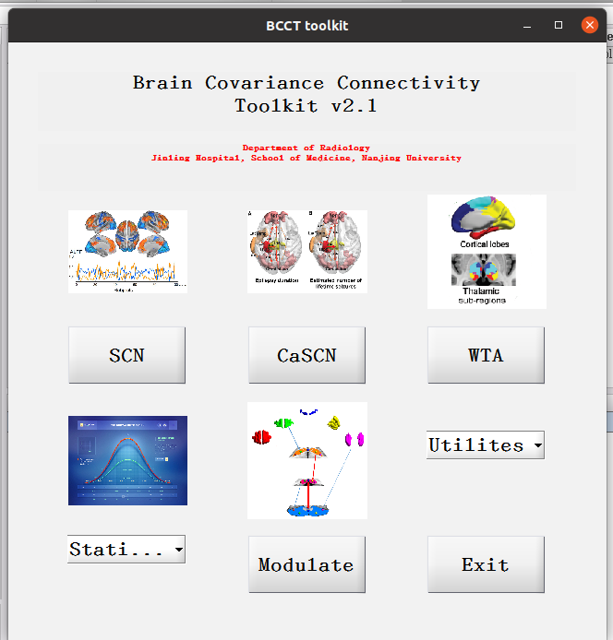After adding the path to matlab, type ‘BCCT’ in command window of matlab and press ‘Enter’ to start the package (Figure 1).

Figure 1

2. Structural Covariance connectivity Network (SCN)

Click ‘SCN’ button to start SCN analysis.

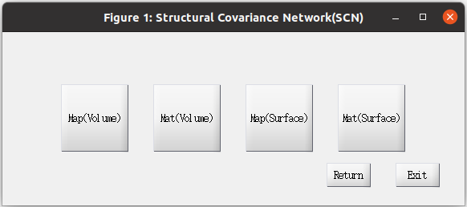There are four kinds of SCN could be selected: Map(Volume) for Nifti type files; Mat(Volume) for Nifti type files with ROIs definition, text files, and mat files; Map(Surface) for mgh type files, such as thickness.*.mgh; Mat(Surface) for mgh type files with ROI definition, text files and mat files. The last button is now under development.

Figure 2

2.1 Map(Volume)

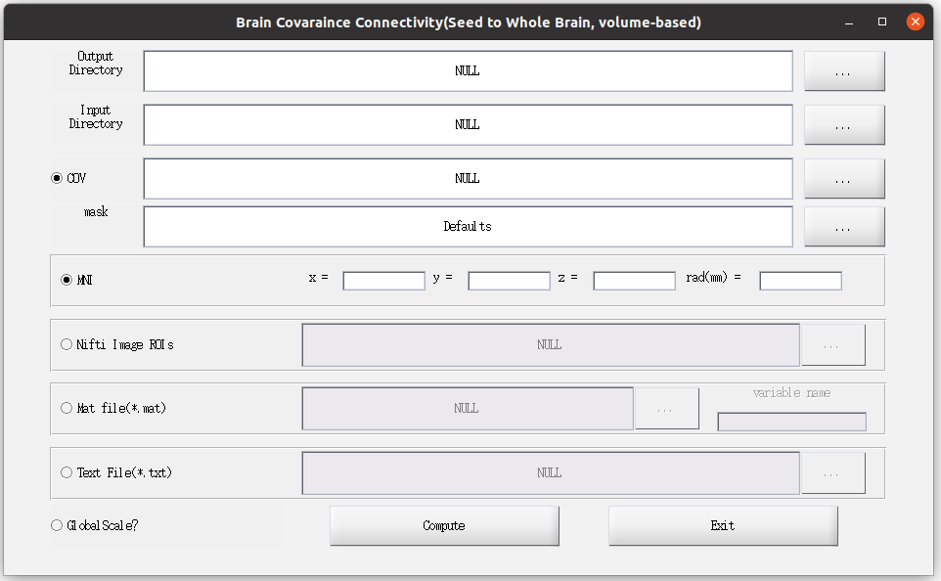Click ‘Map Volume’ to start up the parameter setting up window(Figure 3).

Figure 3

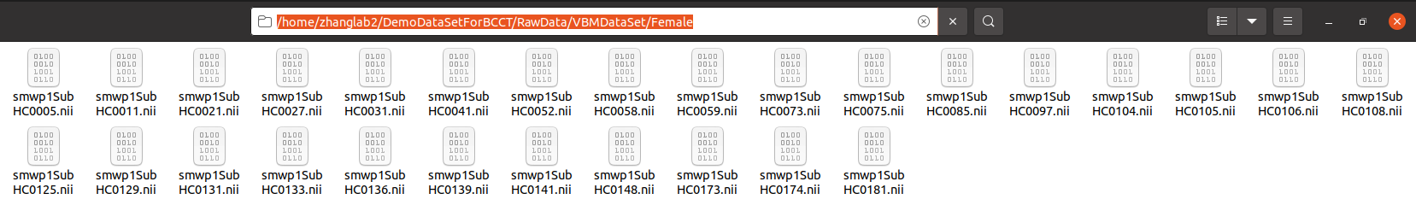Click button ‘…’ to select the paths of output, input. Note that the path of input should be the directory of nifit files, i.e. /home/zhanglab2/DemoDataSetForBCCT/RawData/VBMDataSet/Female (Figure 4)

Figure 4

The support file type of ‘COV’ is text file. If you do not want to regress out anything, just click the ‘COV’ to froze the selection. Note that, do not add into the variable of all-one colume, for the interaction analysis of statistical analysis would gain error results.

The mask file should be the same resolution of the input nifti files. It is suggested that you use ‘Defaults’ for the default mask gained from the package.

There four kinds of ROI definition: MNI, Nifti Image ROIs, Mat file (*.mat), and Text File (*.txt).

In ‘MNI’, ‘x y z’ means the center mni coordinate of the ROI, and ‘rad(mm)’ means the ball radius.

In ‘Nifti Image ROIs’, please select one combined nifti file, which used different values for different ROIs, such as AAL template.

In ‘Mat file(*.mat)’, please select the mat file(matlab) which contained the ROI signals. Note that the variable name of the ROI signals should be type out, i.e. /home/zhanglab2/DemoDataSetForBCCT/RawData/VBM_Mat/SeedToBrain/Female_ROIsignal.mat, where the variable name of ROI signals is ‘ROIsignals’ (Figure 5)

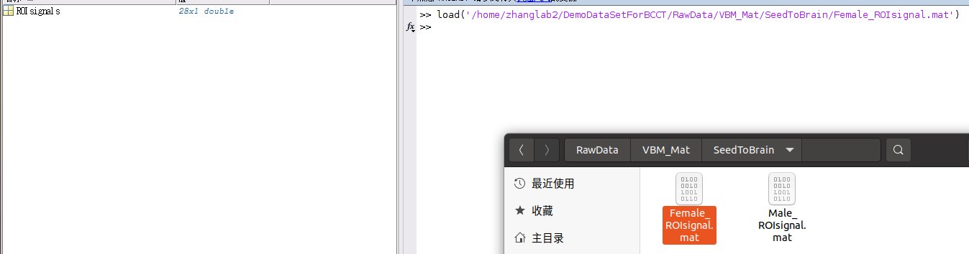In this condition, please type ‘ROIsignals’ to the textbox below ‘variable name’

Figure 5

After setting up, please click ‘Compute’ to run the analysis.

Here we present the MNI (0 -53 30 rad 10) definition (Figure 6), without COV regress out.

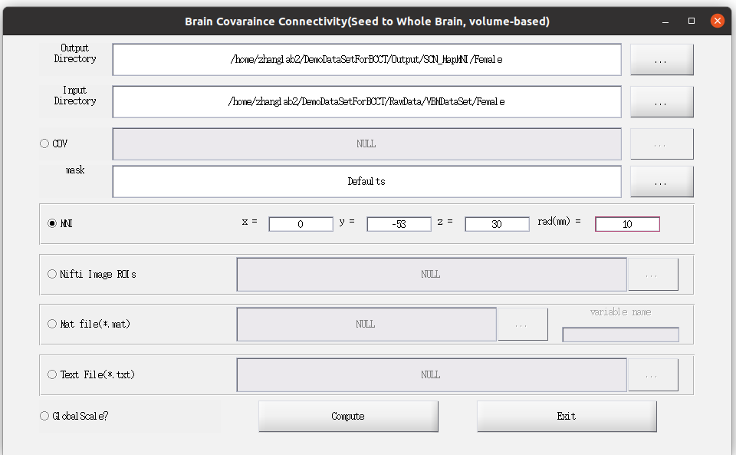Figure 6

2.2 Mat(Volume)

Click ‘Mat(Volume)’ (figure 2) to start up the parameter setting up window(Figure 7).

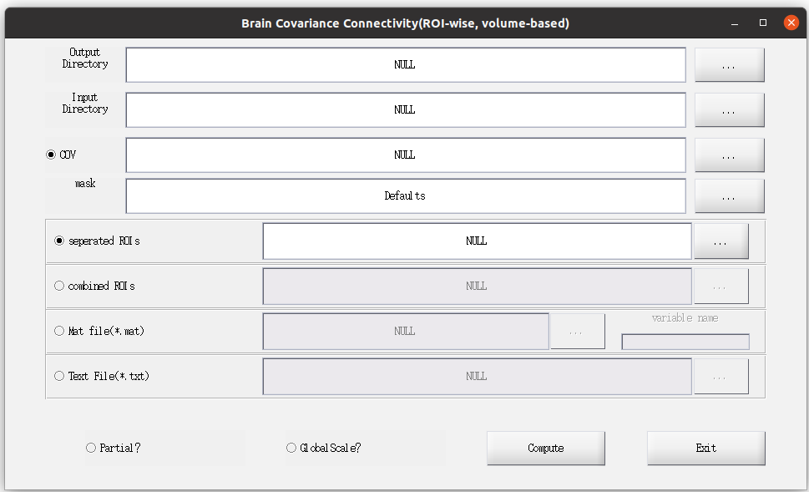Figure 7

Similar to 2.1, Click button ‘…’ to select the paths of output, input. Note that, in Mat file(*.mat) and Text File(*.txt), the Input Directory could be any directory; in first two conditions, the Input Directory selection is the same as that in 2.1(Figure 4).

The support file type of ‘COV’ is text file. If you do not want to regress out anything, just click the ‘COV’ to froze the selection. Note that, do not add into the variable of all-one colume, for the interaction analysis of statistical analysis would gain error results.

There are four kinds of ROI definition: separated ROIs, combined ROIs, Mat file(*.mat) and Text File(*.txt). The operations of Mat file(*.mat) and Text File(*.txt) are the same as those in section 2.1, here we would not discuss it.

For separated ROIs, please put all nifti-type ROI files in one folder, and select the absolute pathway of the folder.

For combined ROIs, please select one combined nifti file, which used different values for different ROIs, such as AAL template.

Additionally, the ROI-wise SCN could do the partial correlation with other ROI signals as variables of no-interest by click ‘Partial?’. Note that, the partial correlation analysis is not suitable for the ROI number similar with, or even larger than the number of participants.

After setting up, please click ‘Compute’ to run the analysis.

Here we present the AAL template as ‘Combined ROIs’ (Figure 8), with TIV as COV to regress out (Figure 8).

2.3 Map(Surface)

Click ‘Map(Surface)’ (figure 2), then click ‘FreeSurfer Standard’ to start up the parameter setting up window(Figure 9).

Other type of Surface files would be added up in later version.



Figure 8

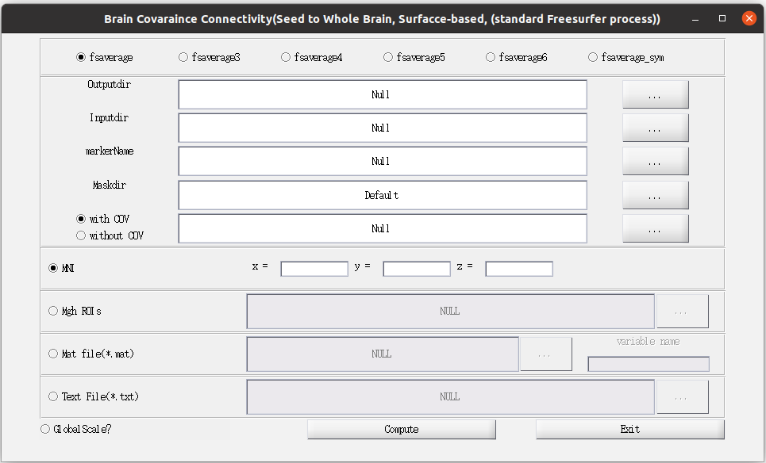

Figure 9

The Map(Surface) setting up window is similar to the Map(Volume) setting up window (Figure 3).

In Map(Surface), you should select the data structure files by selecting one of ‘fsaverage’, ‘fsaverage3’, ‘fsaverage4’, ‘fsaverage5’, ‘fsaverage6’ and ‘fsaverage_sym’.

In Map(Surface), the MNI definition only selects one vertex, the radius would be added in future version of the package.

In the Inputdir selection, please select the standard FreeSurfer output folder, i.e. /home/zhanglab2/DemoDataSetForBCCT/RawData/FreeSurferDataSet/Female

which contained subject names; in each subject folder, there is subfolder ‘surf’, which contained l(r)h.<indices>.fwhm<smooth>.fs.mgh (Figure 10）

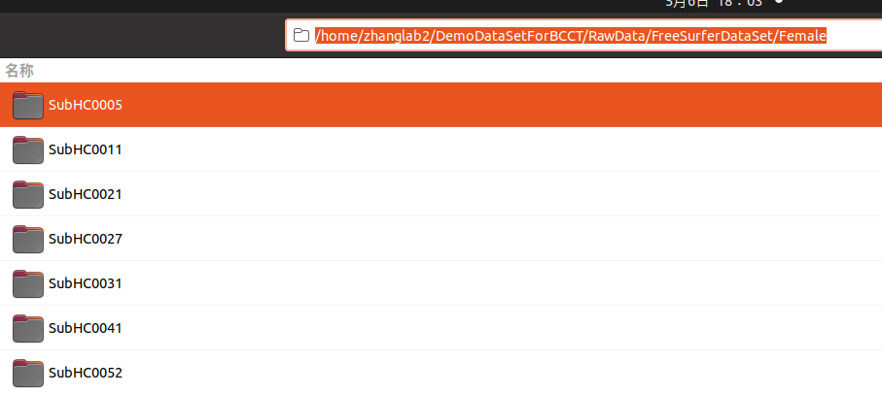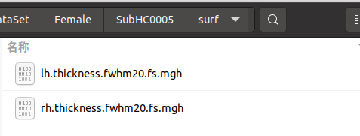Figure 10

After that, select ‘lh.thickness.fwhm20.fs.mgh’ in ‘markername’, which is used to pick up the index of SCN.

After setting up, please click ‘Compute’ to run the analysis.

Here we present the Mat Files(*.mat) (Figure 11), with age as COV to regress out (Figure 11).

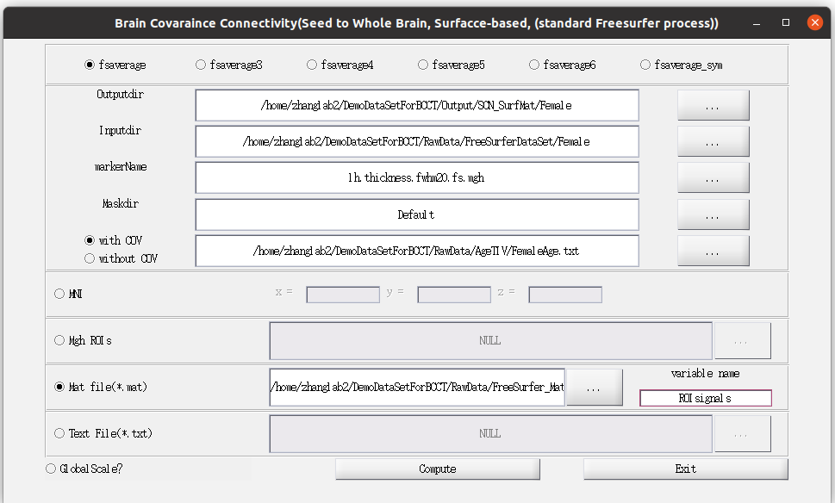Figure 11

2.4 Mat(Surface)

The Mat for Surface mode would coming in future version.

3. Causality analysis of Structural Covariance connectivity Network (CaSCN)

Click ‘CaSCN’ button to start CaSCN analysis.

Same with SCN mode, there are four kinds of CaSCN analysis. And similar, the Mat(Surface) mode is now under development.

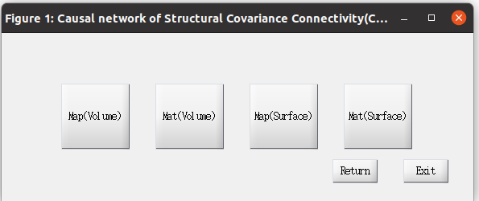

Figure 12

3.1 Map(Volume)

Click ‘Map Volume’ to start up the parameter setting up window(Figure 13).

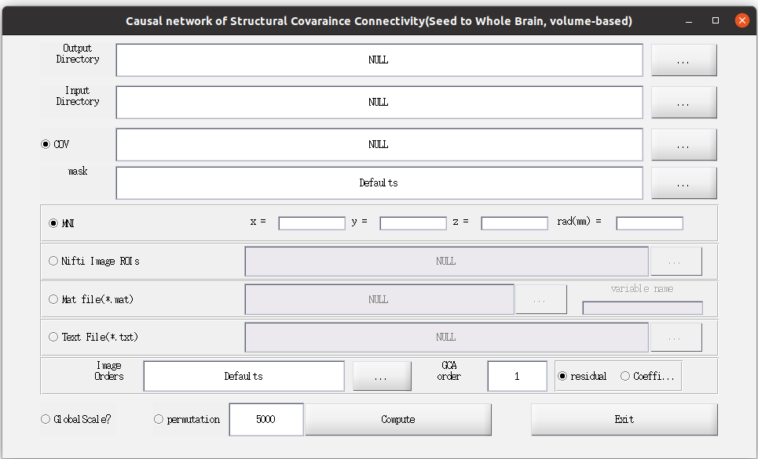Figure 13

The ROI selection and COV selection are the same as those in 2.1.

For Granger Causality analysis, the two methods of GCA could be selected: residual-based and Coefficient-based GCA. The differences could be found in the reference papers.

The GCA analysis also needs the difference order, it is suggested that used the default 1 (‘GCA order’) to do the analysis.

The Image Orders could change the input images orders. The ‘Defaults’ means 1,2,3,…,n (1:n). The ‘Image Orders’ needs text file to be upload to the package. The package would sort the images according the ‘Image Orders’; i.e., select the age as the Image Orders, the images would be re-grouped by age.

Note: ‘permutation’ would cost a lot of time. The ‘permutation’ would regroup the images to build a null distribution to calculate the significance of the CaSCN.

After setting up, please click ‘Compute’ to run the analysis.

Here we present the MNI (0 -53 30 rad 10) definition, using age as image order, residual-based GCA, with permutation 100 times, without COV regress out (Figure 14).

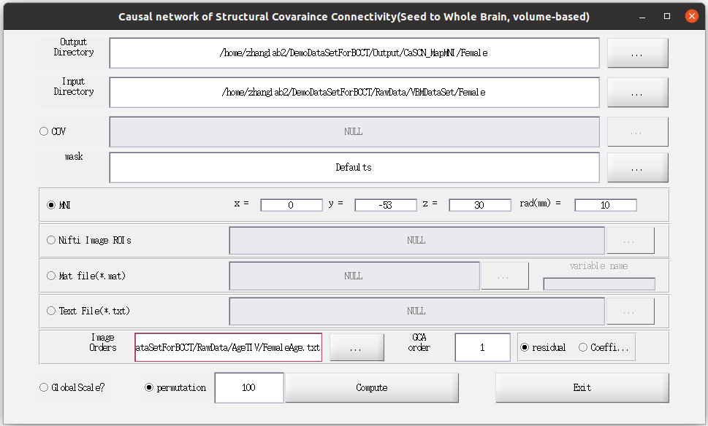Figure 14

3.2 Mat(Volume)

Click ‘Mat(Volume)’ (figure 12) to start up the parameter setting up window(Figure 15).

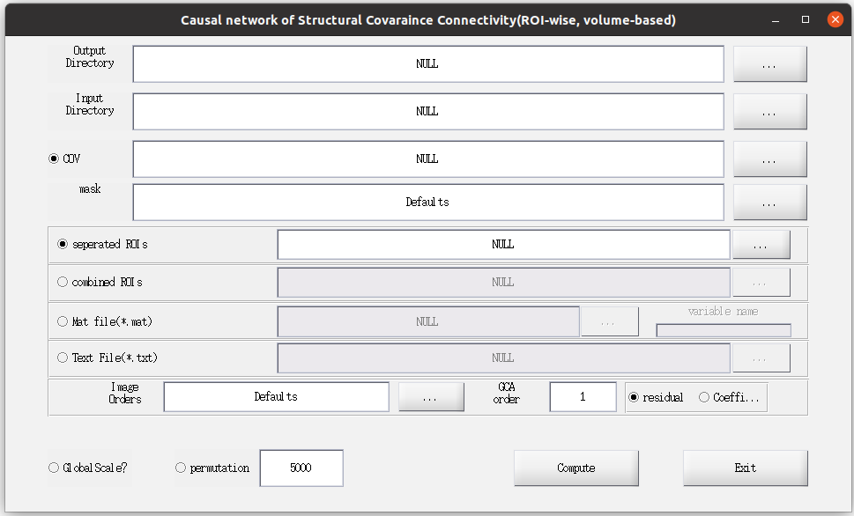Figure 15

The ROI selection and COV selection are the same as those in 2.2.

The GCA operations are the same as those in 3.1.

After setting up, please click ‘Compute’ to run the analysis.

Here we present the separated ROIs, with age as image orders, Coefficient-based GCA, with TIV as COV, and with 200 permutation. (Figure 16)

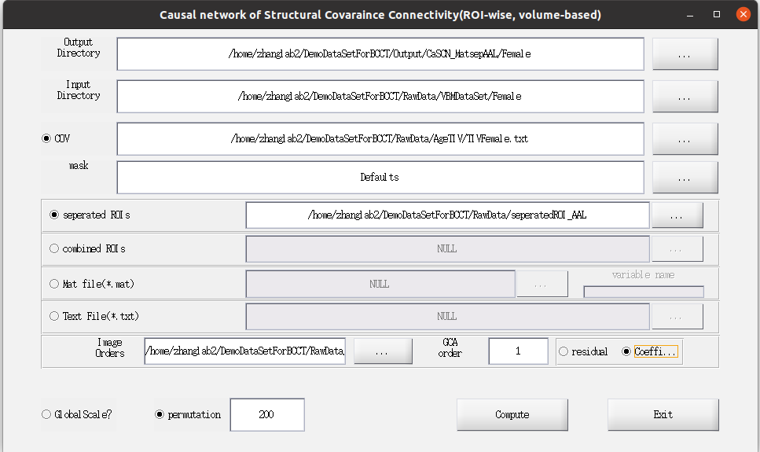Figure 16

3.3 Map(Surface)

Click ‘Map(Surface)’ (figure 12), then click ‘FreeSurfer Standard’ to start up the parameter setting up window(Figure 17).

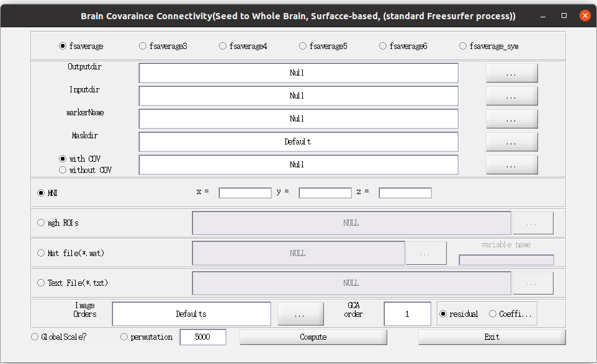Figure 17

The ROI selection, COV selection and images selection are the same as those in 2.3.

The GCA operations are the same as those in 3.1.

Here we present the text file as seed ROI, without COV, using Defaults as Image Orders, using residual-based GCA, and without permutation.(Figure 18)

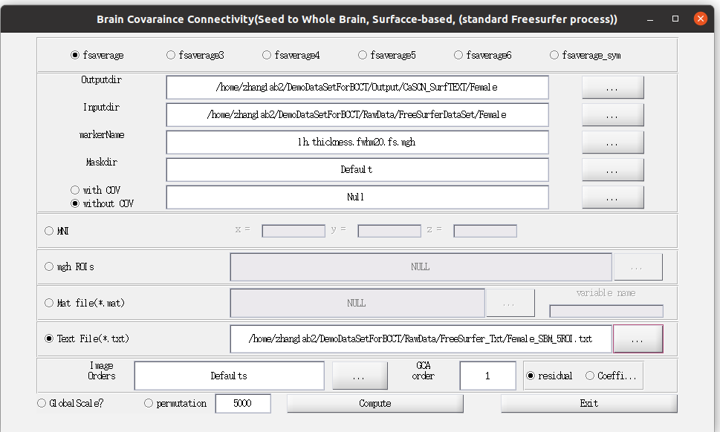Figure 18

3.4 Mat(Surface)

The Mat for Surface mode would coming in future version.

4. Cortex-to-SubCortex Structural covariance connectivity&Winnter Take All (WTA-CSSCN)

Click ‘WTA’ button to start Cortex-to-SubCortex Structural covariance connectivity&Winnter Take All analysis (Figure 19).

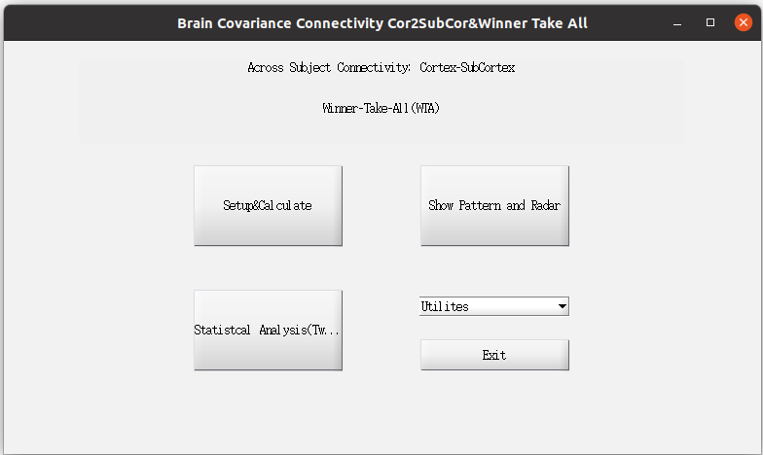Figure

There are three main functions in this window(Figure 19): ‘SetUp&Calculate’ for set-up parameter and calculate the WTA-CSSCN analysis; ‘Show Pattern and Rader’ for result showing; ‘Statistical Analysis(Two group)’ for two-group comparison of WTA-CSSCN.

Here only introduce the SetUp&Calculate, the Show Pattern and Rader would be introduced in 7 Result Showing, and the Statistical Analysis(Two group) would be introduced in 6 Statistical Analysis.

Click ‘SetUp&Calculate’ to start the parameter set up window(Figure 20)

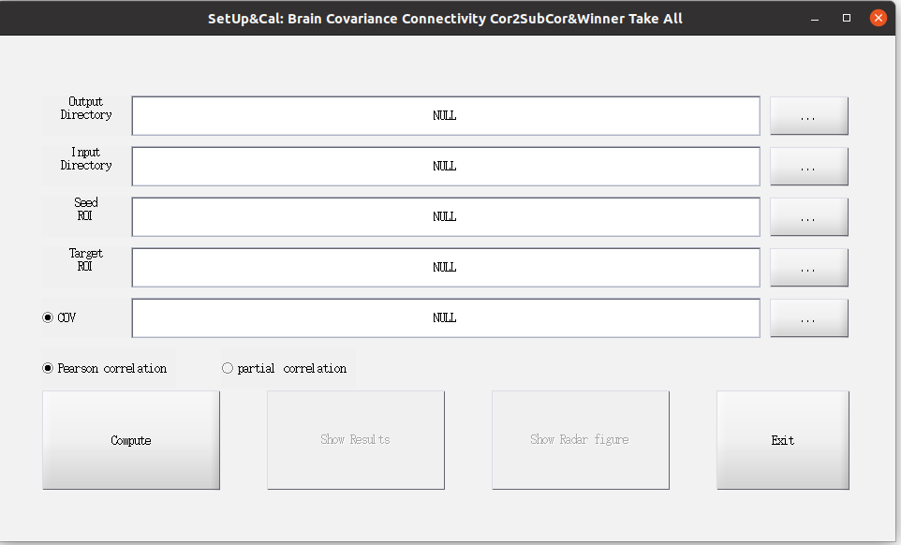Figure 20

Note: WTA-CSSCN only support volume-based nifti images currently.

The Input/Output Directory and COV selections are same as that in 2.1.

Seed ROI: Cortex ROI, combined multi-value nifti image

Target ROI: Subcortex ROI, combined multi-value nifti image

Two kinds of correlation method are used for the analysis, Pearson correlation and Partial correlation. For Partial correlation, only the signals of seed ROI are regress out as covariance of no interest.

Here we present combined 5 cortex ROI as Seed ROI, Striatum-Thalamus-Cerebellum as Target ROI, TIV as COV, and using Pearson correlation.(Figure 21). After setting up, click ‘Compute’

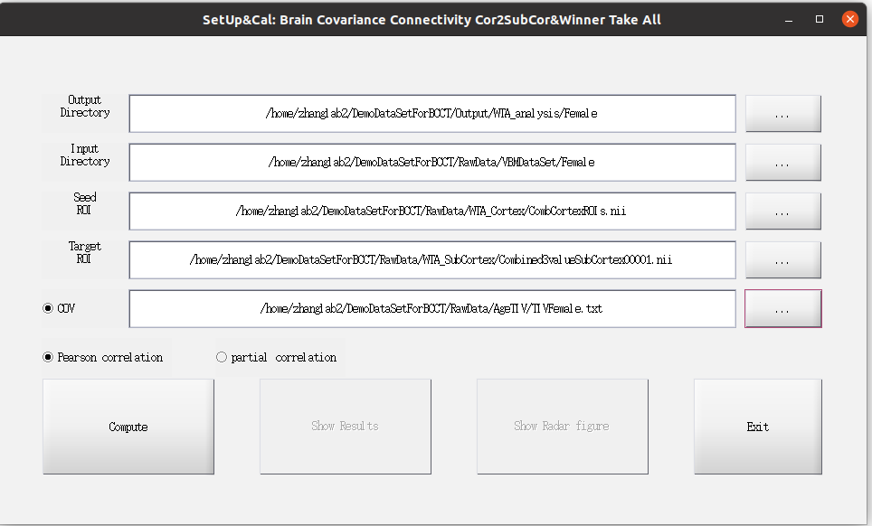Figure 21

5. Modulation of Structural Covariance connectivity Network (MOD-SCN)

Click ‘MOD’ button to start MOD-SCN analysis.

Same with SCN mode, there are four kinds of MOD-SCN analysis. And similar, the Mat(Surface) mode is now under development.

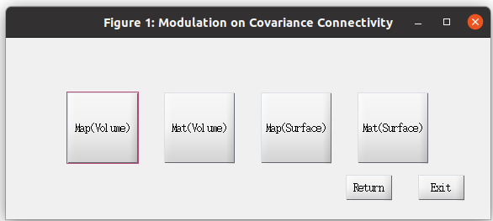Figure 22

5.1 Map(Volume)

Click ‘Map Volume’ to start up the parameter setting up window(Figure 23).

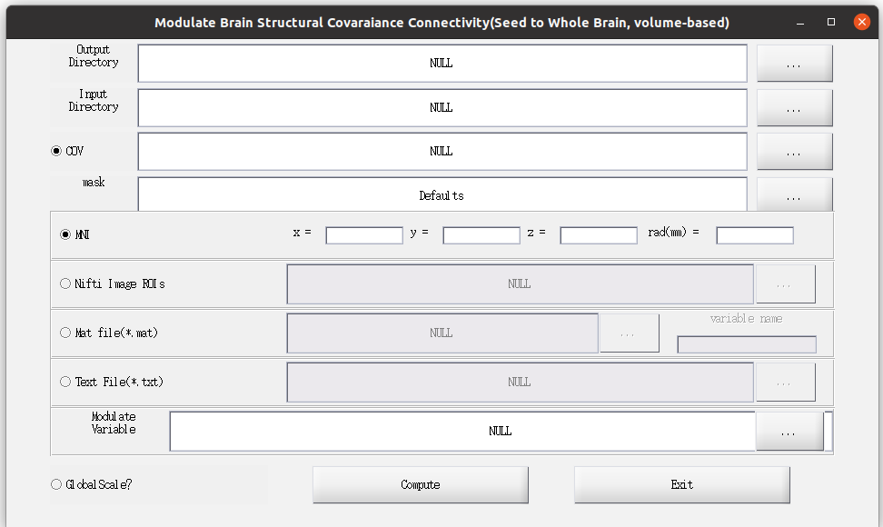Figure 23

The ROI selection and COV selection are the same as those in 2.1.

The ‘Modulate Variable’ is the variable to modulate the connectivity, i.e. the age.

After setting up, please click ‘Compute’ to run the analysis.

Here we present the MNI (0 -53 30 rad 6) definition, using age as modulate variable,with TIV as COV to regress out (Figure 24).

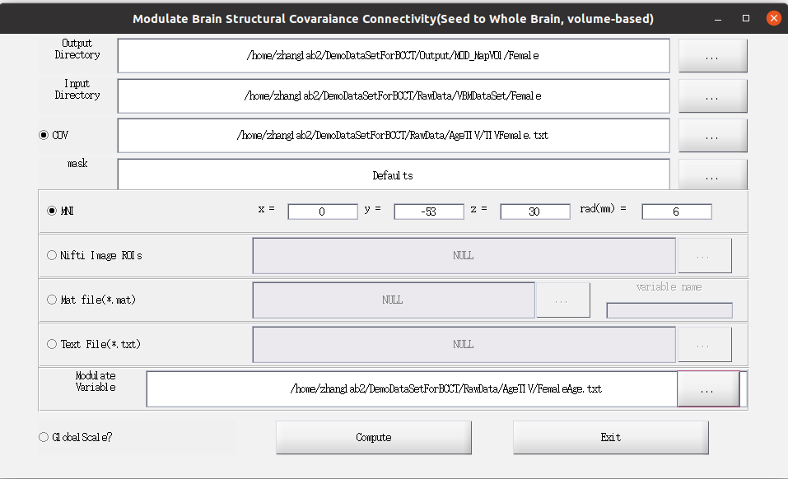Figure 24

5.2 Mat(Volume)

Click ‘Mat(Volume)’ (figure 22) to start up the parameter setting up window(Figure 25).

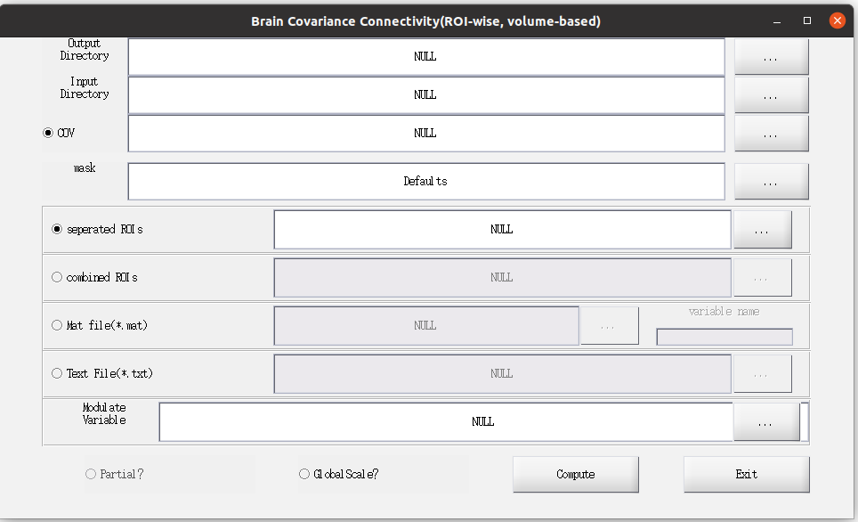

Figure 25

The ROI selection and COV selection are the same as those in 2.2.

Additionally, the ROI-wise MOD-SCN could do the partial correlation with other ROI signals as variables of no-interest by click ‘Partial?’. Note that, the partial correlation analysis is not suitable for the ROI number similar with, or even larger than the number of participants.

After setting up, please click ‘Compute’ to run the analysis.

Here we present the combined AAL template, with age as Modulate Variable, without COV to regress out. (Figure 26)

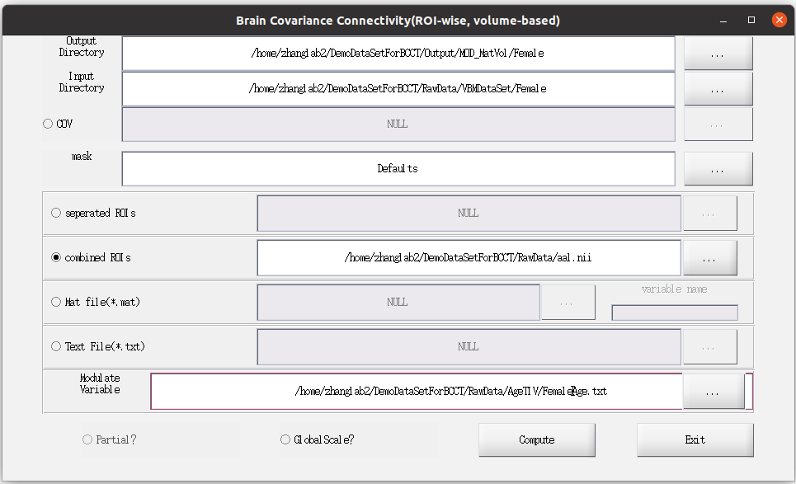Figure 26

5.3 Map(Surface)

Click ‘Map(Surface)’ (Figure 22), then click ‘FreeSurfer Standard’ to start up the parameter setting up window(Figure 27).

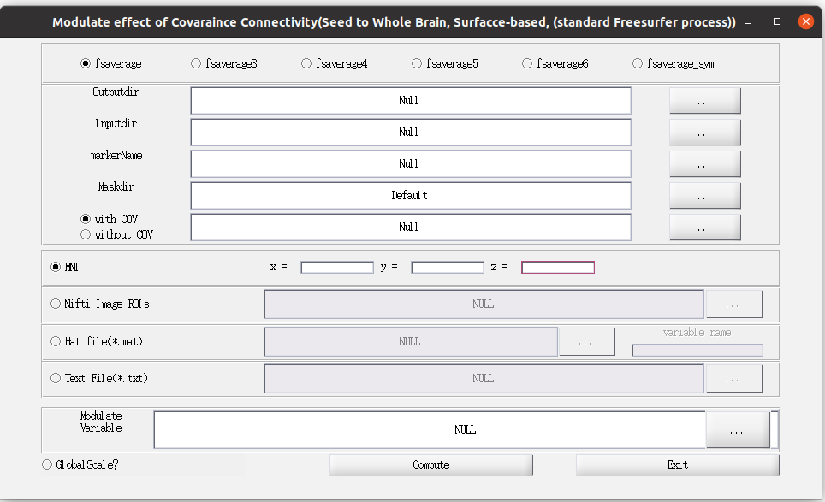Figure 27

The ROI selection, COV selection and images selection are the same as those in 2.3.

After setting up, please click ‘Compute’ to run the analysis.

Here we present MNI (0 -53 30) as seed ROI, with age as Modulate Variable, without COV.(Figure 28)

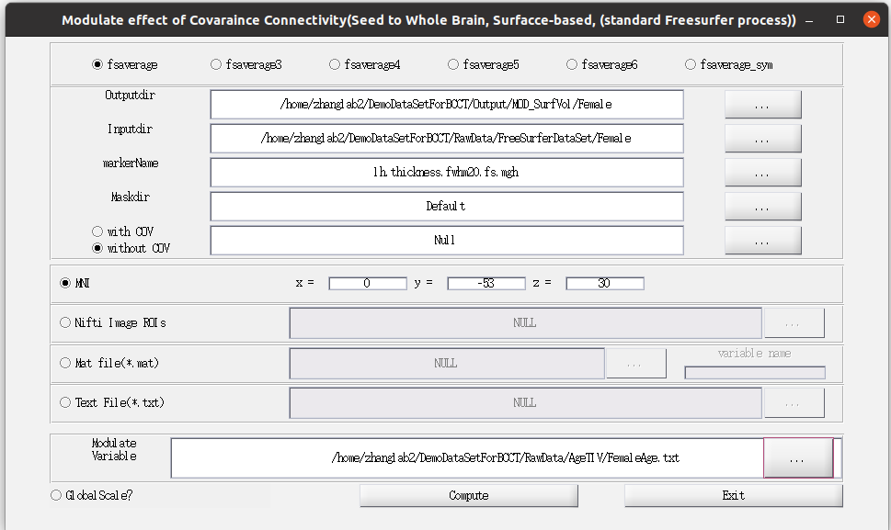Figure 28

5.4 Mat(Surface)

The Mat for Surface mode would coming in future version.

6. Statistical Analysis

Currently, the Package only supports the group comparison of two groups.

6.1 SCN comparison

Click the pull-down manual of Statistics, and select ‘SCN’ to start the SCN comparison window (Figure 29).

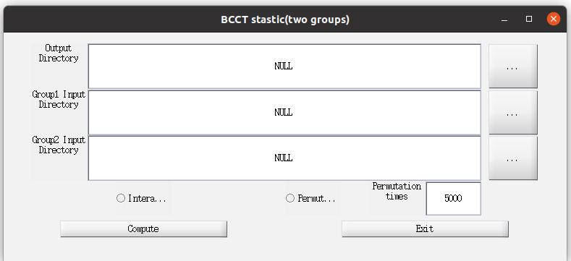Figure 29

All SCN comparisons are using the same window for setting up. Make sure that the Group1 and Group2 use the same parameter for computing. The package would gain the setup parameter of Group1 for later analysis.

Two kinds of group comparison methods could be used for the comparison, Interaction and Permutation. Using both methods is OK for the package.

In the demo dataset, for Map(Volume), we present the interaction method (Figure 30); for Mat(Volume), we present interaction and permutation (5000 times) (Figure 31); for Map(Surface), we present permutation (100 times) (Figure 32).

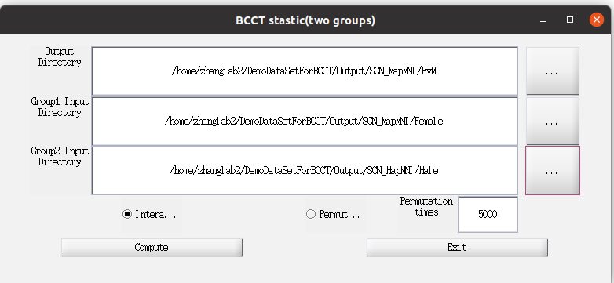Figure 30

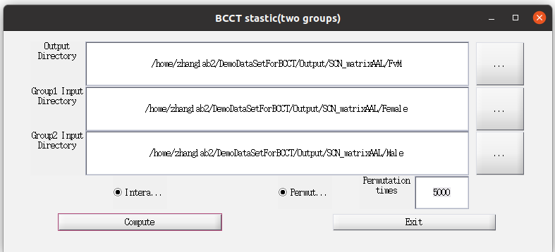Figure 31

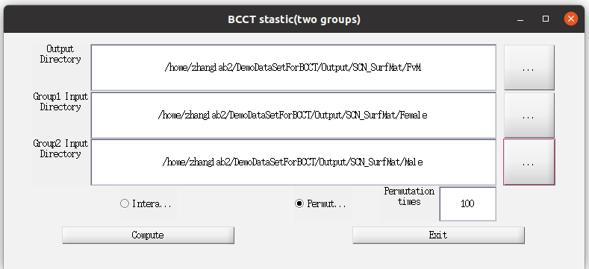Figure 32

6.2 CaSCN comparison

Click the pull-down manual of Statistics, and select ‘CaSCN’ to start the CaSCN comparison window (Figure 33).

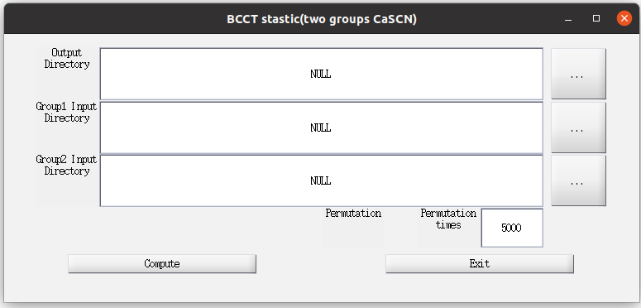Figure 33

All CaSCN comparisons are using the same window for setting up. Make sure that the Group1 and Group2 use the same parameter for computing. The package would gain the setup parameter of Group1 for later analysis.

Only Permutation test is available for the CaSCN comparison.

In the demo dataset, for Map(Volume), we present permutation (100 times) (Figure 34); for Mat(Volume), we present permutation (100 times) (Figure 35); for Map(Surface), we present permutation (100 times) (Figure 36).

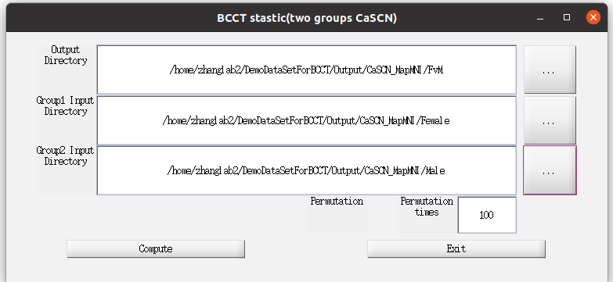Figure 34

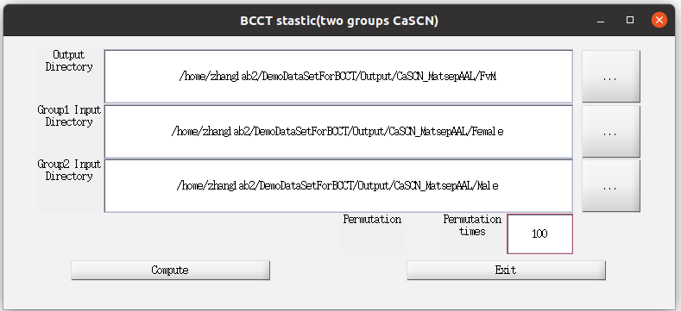Figure 35

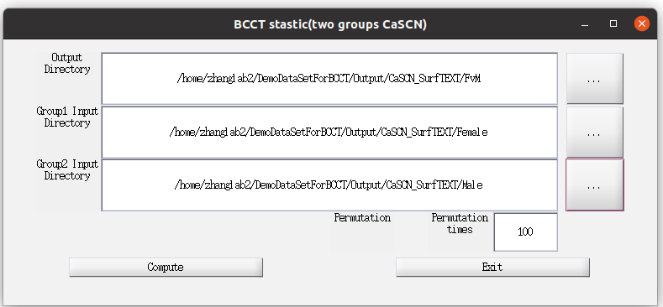Figure 36

6.3 WTA-CSSCN comparison

Click the pull-down manual of Statistics, and select ‘WTA’ to start the WTA-CSSCN comparison window (Figure 37).

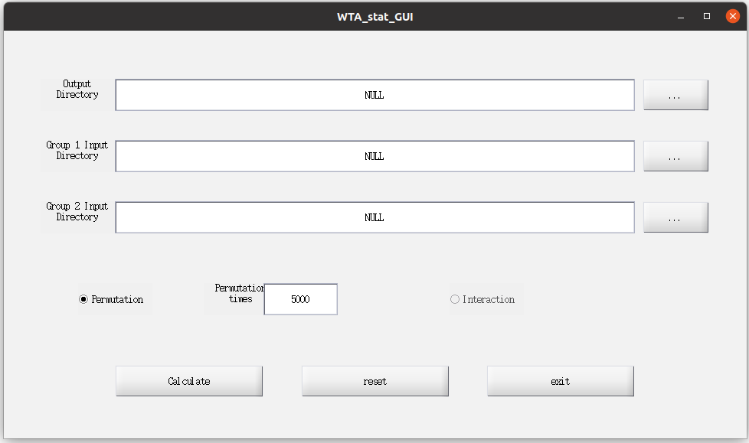Figure 37

Only Permutation test is available for the CaSCN comparison.

In the demo dataset, we present Permutation (100 times) for the group comparison of numbers of connectivity voxels corresponding to the seed ROIs

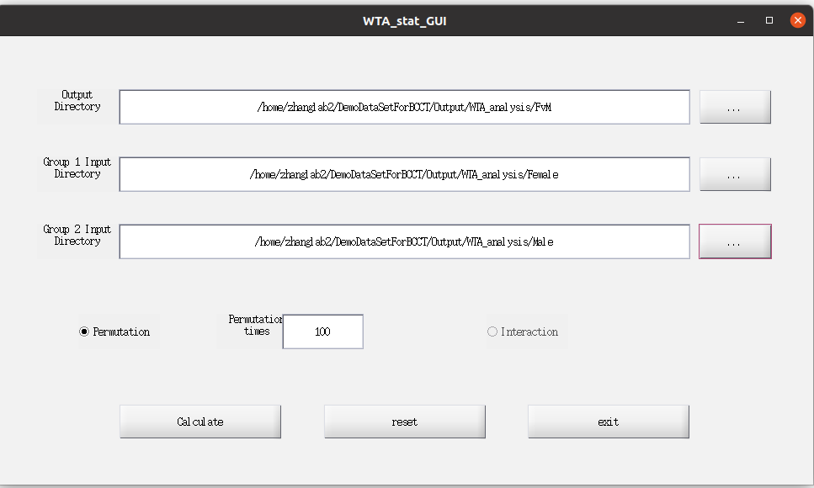Figure 38

6.4 MOD-SCN comparison

Click the pull-down manual of Statistics, and select ‘MOD’ to start the WTA-CSSCN comparison window (Figure 39).

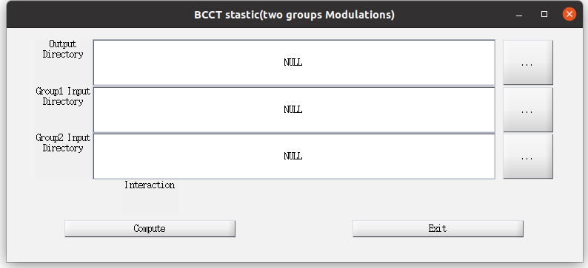Figure 39

All MOD-SCN comparisons are using the same window for setting up. Make sure that the Group1 and Group2 use the same parameter for computing. The package would gain the setup parameter of Group1 for later analysis.

Only Interaction test is available for the MOD-SCN comparison.

In the demo dataset, interaction test for two groups are present for Map(Volume) (Figure 40), Mat(Volume) (Figure 41), and Map(Surface) (Figure 42).

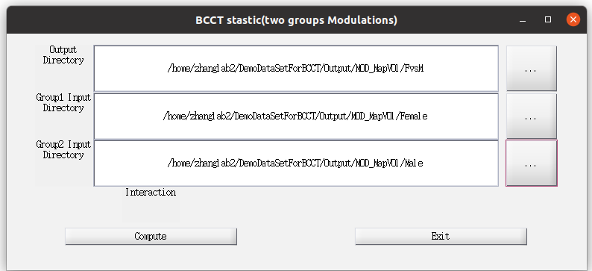Figure 40

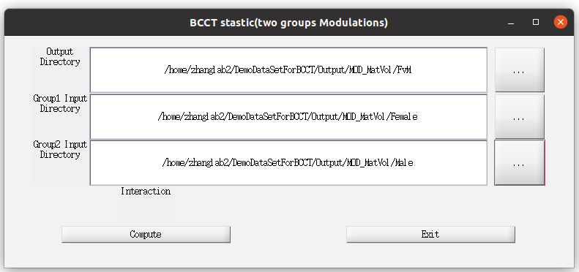Figure 41

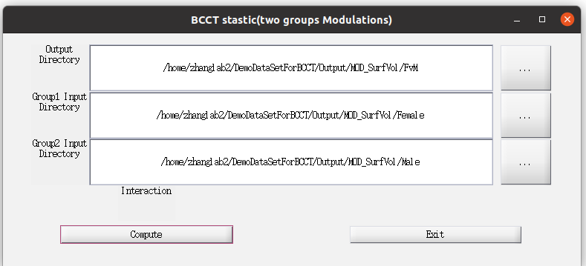Figure 42

7. Result Showing

Click the pull-down manual of Utilities, and select ‘Viewer’ to start the Volume&Mat Showing window (Figure 43).

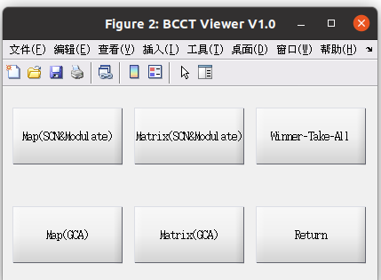Figure 43

Click the pull-down manual of Utilities, and select ‘View for Surface’ to start the Surface Showing window (Figure 44).

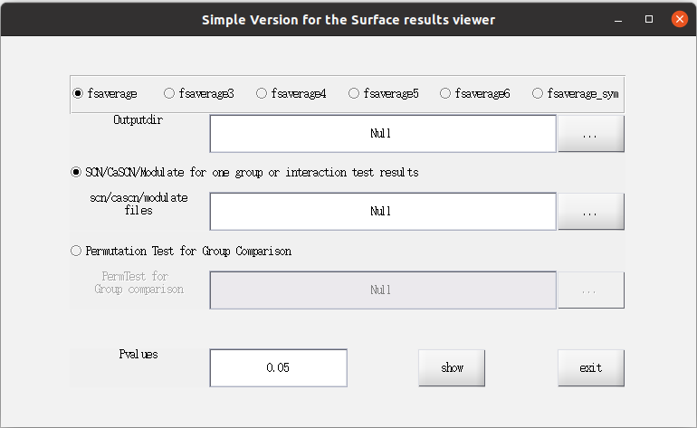Figure 44

Click the ‘WTA’, the Click ‘Show Patter and Radar’ (Figure 45) and open the information collection window(Figure 46)

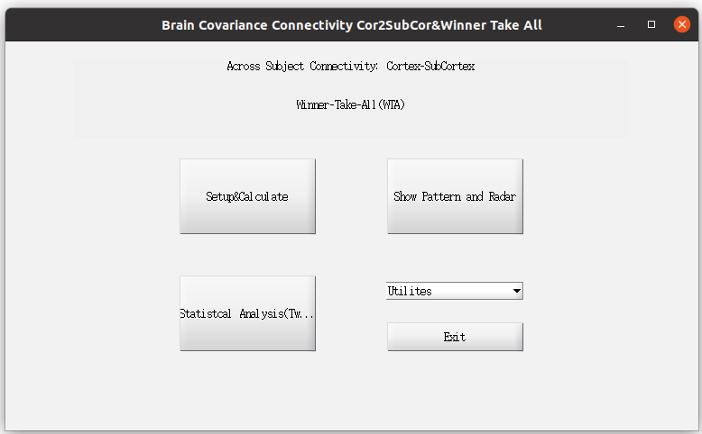Figure 45

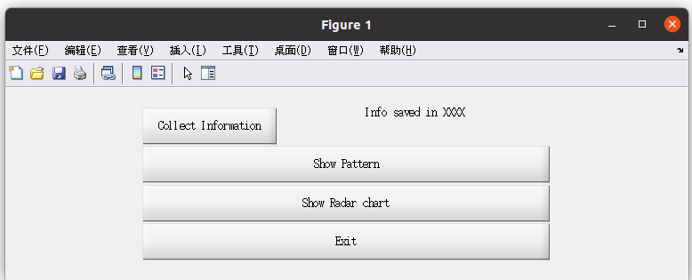Figure 46

For Volume&Mat Showing window, the SCN and MOD-SCN share the same input window, WTA-CSSCN and CaSCN use their own windows.

For Surface Showing window, SCN, MOD-SCN and CaSCN use the same window.

7.1 Map(SCN&Modulate)

Click ‘Map(SCN&Modulate)’ to open the Showing window (Figure 47)

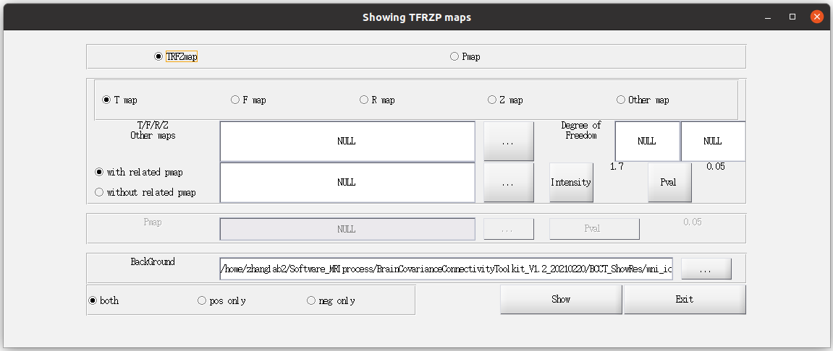Figure 47

7.1.1 SCN Map(Volume)

Result folder(Figure 48):

R_ROI000000X.nii: Rmap of ROIX

Z_ROI000000X.nii: Zmap of ROIX (Fisher-z transform)

P_ROI000000X.nii: related Pmap of ROIX

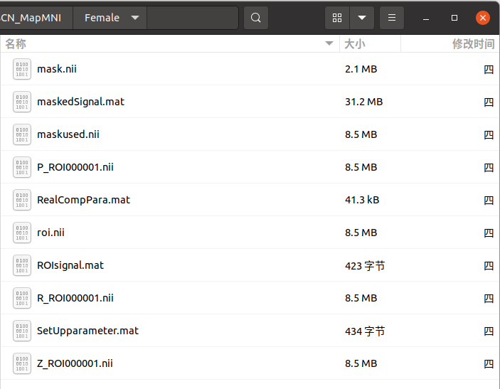Figure 48

**7.1.1.a Select ‘R map’ & ‘with related pmap’**

Select ‘TRFZmap’, ‘R map’, ‘with related pmap’

Click the select button ‘…’ after ‘T/F/R/Z Other maps’ to pick the Rmap file.

after selection, type the degree of freedom for showing(Figure 49). The dof = n-2-number of cov

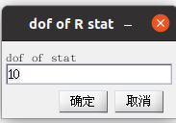Figure 49

Click the select button ‘…’ after ‘with related pmap’ to select the related p map file

Click ‘Intensity’ could alter the minimal threshold of Rmap

Click ‘Pval’ could alter the minimal threshold of related Pmap to alter the minimal threshold of Rmap

Click ‘…’ after ‘BackGround’ could change the back ground template. It is suggested to use the default back ground map.

Click ‘both’ to show both positive and negative values of the Rmap.

Click ‘pos only’ to show only positive values of the Rmap.

Click ‘neg only’ to show only negative values of the Rmap.

Here we present ‘Rmap’, ‘with related pmap’, ‘Pval’ = 0.01, ‘both’ to show the result of 2.1 (Figure 50).

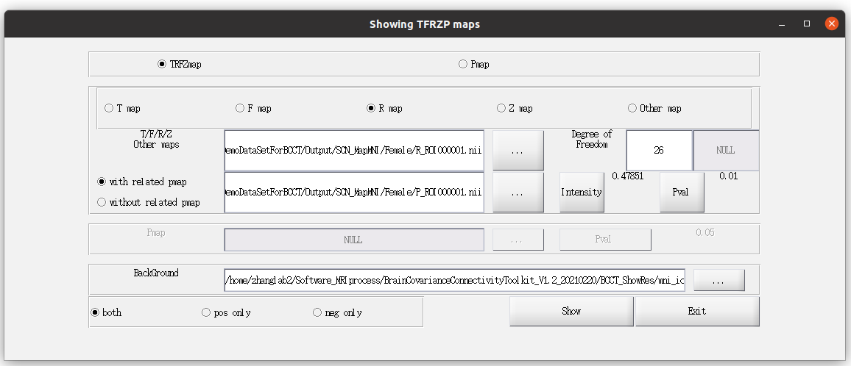Figure 50

Then the main result showing window(Figure) and control window(Figure 51) appear.

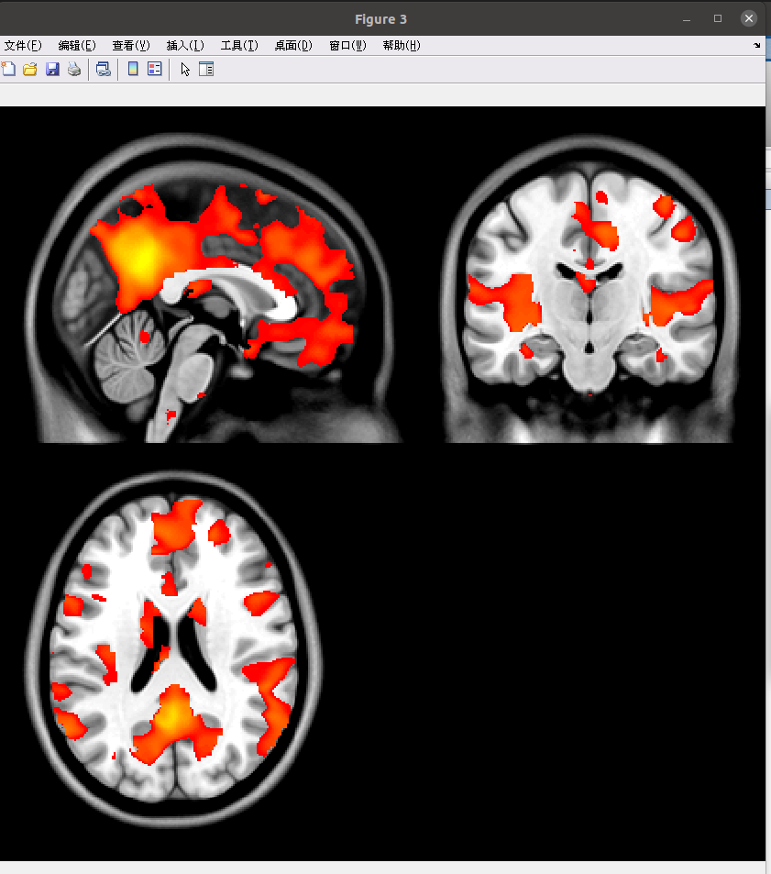Figure 51

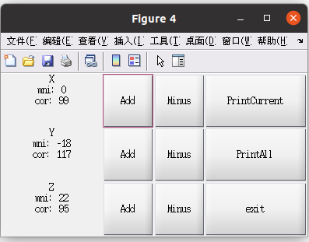Figure 52

Click ‘Add’/‘Minus’ to change the related slice in Figure 52.

Click ‘PrintCurrent’ to select the outputdirectory (Figure 53), the package would save the current Figure X to the outputdirectory, with the name ‘current<year><mon><data><hour><min>.tif’, i.e. current2021581126.tif

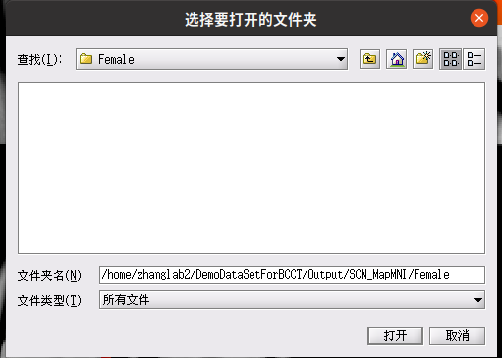Figure 53

Click ‘PrintAll’ to select the outputdirectory (Figure 53), the package would save all slices in x, y and z. In outputdirctory, the slices are saved as x-?.tif, y-?.tif, and z-?.tif. All the tif files are 300 dpi.

**7.1.1.b Select ‘Z map’ & ‘with related pmap’**

Select ‘TRFZmap’, ‘Z map’, ‘with related pmap’

Click the select button ‘…’ after ‘T/F/R/Z Other maps’ to select the related Zmap file.

Similar to 7.1.1.a, select the related Pmap and exchange the threshold of intensity and pvalue.

Here we present ‘Zmap’, ‘with related pmap’, ‘Pval’ = 0.05, ‘pos only’ to show the result of 2.1 (Figure 54).

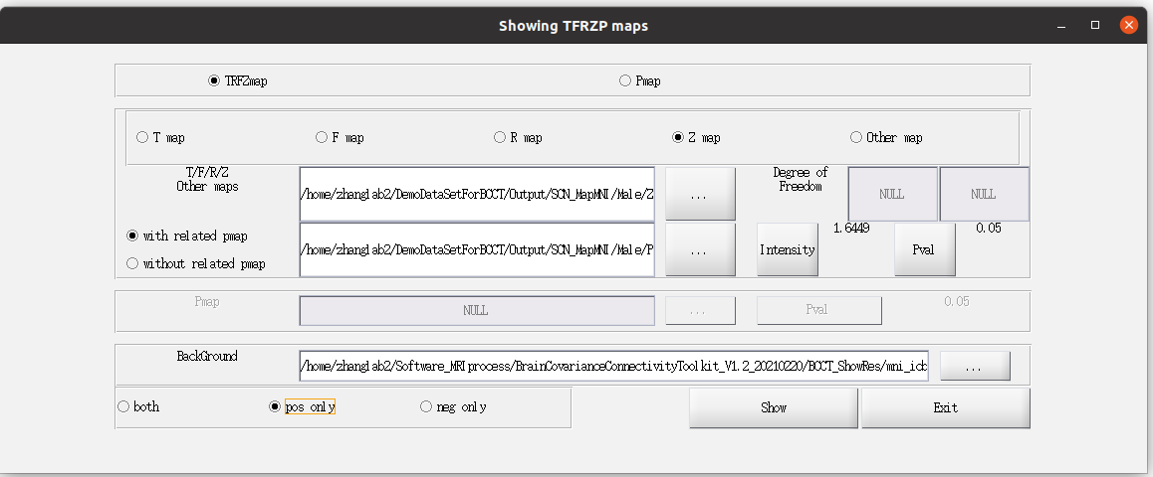Figure 54

Similar to 7.1.1.a, change slice by using the control window, and print the related slices by using ‘Print Current’ and ‘Print All’.

7.1.2 Group difference between Two groups of SCN Map(Volume)

In the interaction comparison result folder:

T_ROI000000X.nii: Tmap of ROIX

Z_ROI000000X.nii: Zmap of ROIX

P_ROI000000X.nii: related Pmap of ROIX

In the permutation comparison result folder:

PermP_ROI000000X.nii: p value map of ROIX

**7.1.2.a interaction analysis (Tmap)**

Select ‘TRFZmap’, ‘T map’, ‘with related pmap’

Click the select button ‘…’ after ‘T/F/R/Z Other maps’ to pick the Tmap file.

Similar to 7.1.1.a, select the related Pmap and exchange the threshold of intensity and pvalue.

Note that the related Pmap<threshold means significant change.

Here we present ‘Tmap’, ‘with related pmap’, ‘Pval’ = 0.05, ‘Both’ to show the result of 6.1 (Figure 55)

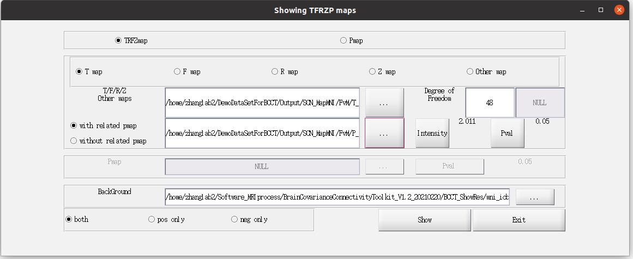Figure 55

Similar to 7.1.1.a, change slice by using the control window, and print the related slices by using ‘Print Current’ and ‘Print All’.

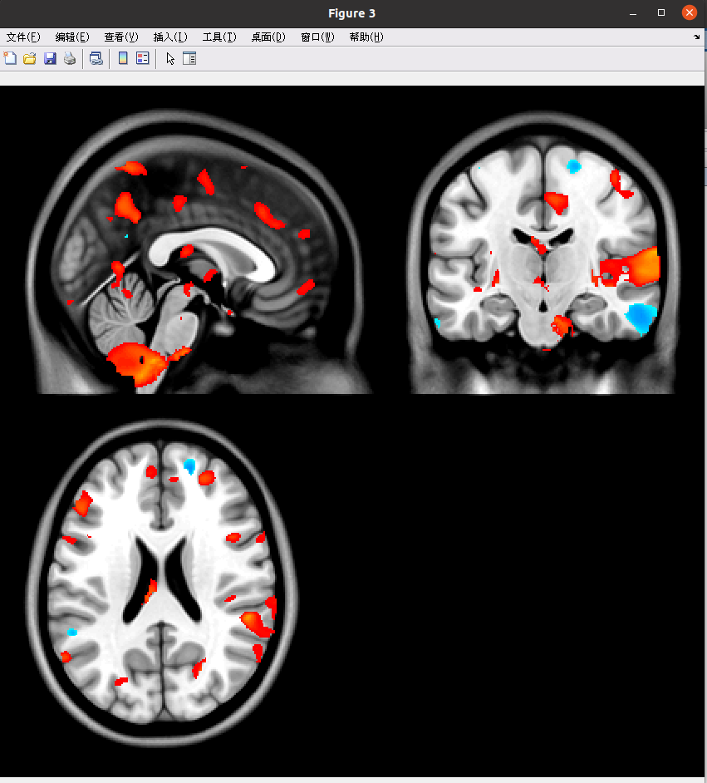Figure 56 Results of Tmap with P<0.05

**7.1.2.b interaction analysis (Zmap)**

The related operations are the same as those in 7.1.1.b.

**7.1.2.c permutation test (perm p value)**

Select ‘Pmap’

Click the select button ‘…’ after ‘Pmap’ to pick the Permutation Pmap file (Figure 57).

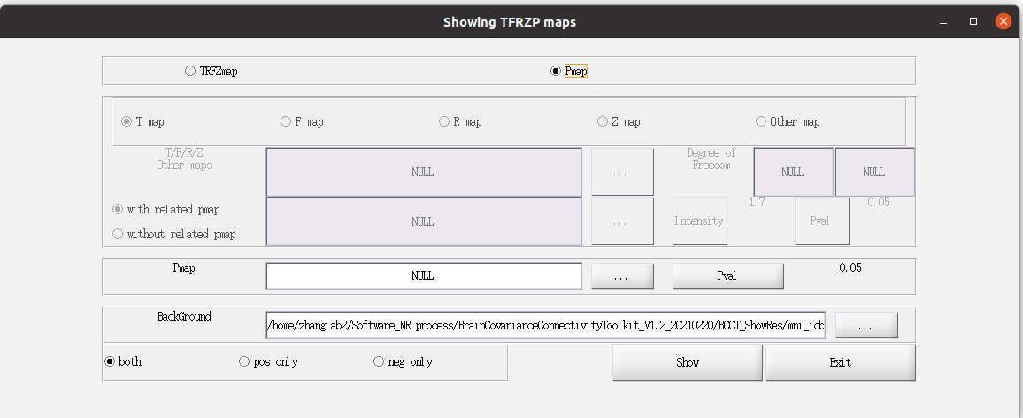Figure 57

Click ‘Pval’ could alter the minimal threshold of related Pmap to alter the minimal threshold of Permutation Pmap. Note that, the permutation pmap < threshold means Group1 < Group2, while permutation pmap > 1-threshold means Group1 > Group2.

Here we present ‘Pval’ = 0.05, 100 permutation times, and ‘both’ to show the result of Female vs. Male (Figure 58).

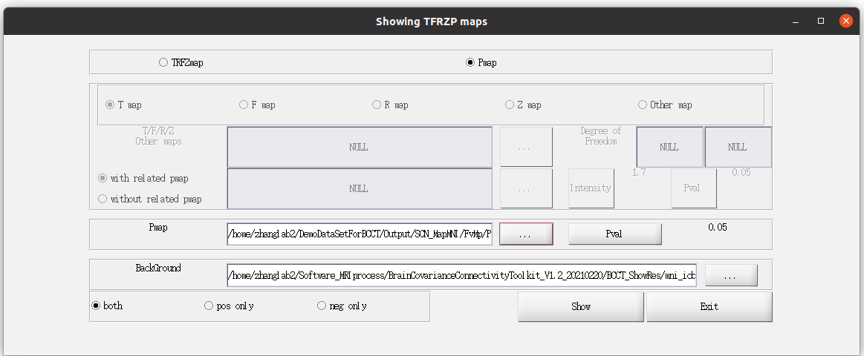Figure 58

Similar to 7.1.1.a, change slice by using the control window, and print the related slices by using ‘Print Current’ and ‘Print All’.

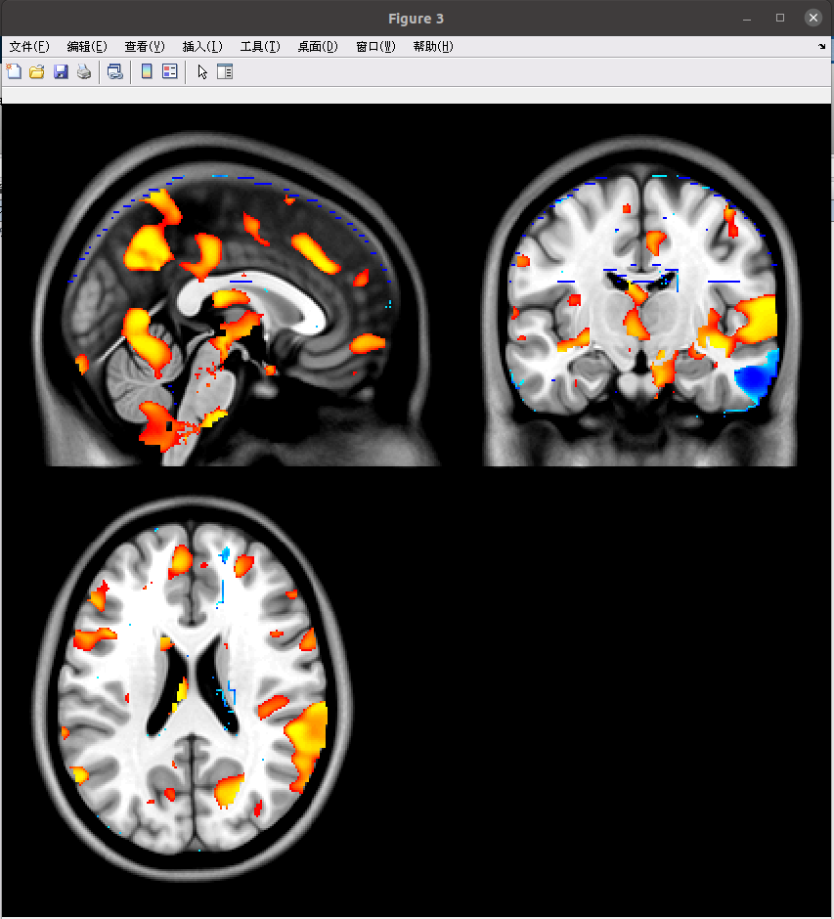Figure 58 Permutation Test Result

7.1.3 MOD-SCN Map(Volume)

Result folder(Figure 59):

T_ROI000000X.nii: Tmap of ROIX

Z_ROI000000X.nii: Zmap of ROIX

P_ROI000000X.nii: related Pmap of ROIX

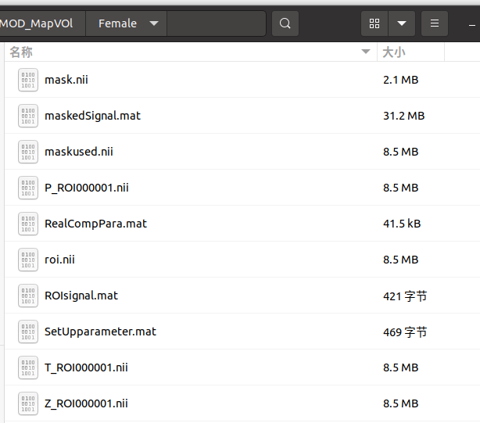Figure 59

The showing of Tmap and Zmap are the same as those in 7.1.2.a and 7.1.1.b.

Note that the related Pmap<threshold means significantly modulation effect.

7.1.4 Group Difference between Two groups of MOD-SCN Map(Volume)

Result folder:

T_ROI000000X.nii: Tmap of ROIX

Z_ROI000000X.nii: Zmap of ROIX

P_ROI000000X.nii: related Pmap of ROIX

The showing of Tmap and Zmap are the same as those in 7.1.2.a and 7.1.1.b.

Note that the related Pmap<threshold means significantly changes between two groups.

7.2 Matrix(SCN&Modulate)

Click ‘Matrix(SCN&Modulate)’ to open the Showing window (Figure 60)

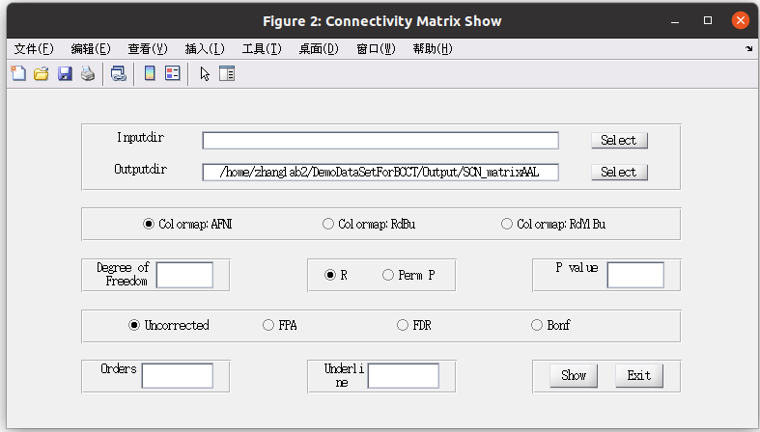Figure 60

7.2.1 SCN matrix (volume)

Result folder (Figure 61):

R_Pres.mat: R/P/Z(fisher Z-transform), DF_E(degree of freedom)

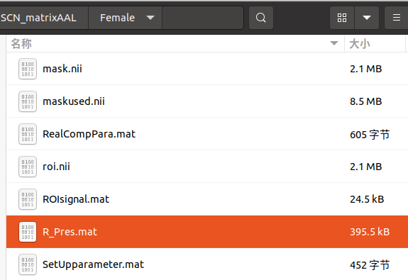

Figure 61

Click ‘Select’ after Inputdir, select ‘R_Pres.mat’ in result folder.

Click ‘Select’ after Outputdir, select the output directory.

Three kinds of colormap could be used: AFNI, RdBu and RdYlBu.

For SCN use ‘R’ mode for the result showing.

Four kinds of threshold are supplied, uncorrect, FPA (p<1/n), FDR and Bonf.

‘Orders’ means the order of the nodes. ‘Underline’ means the enhanced line of subnetwork.

Here, we present results of 2.2 with the FPA corrected, RdBu colormap, with 30 60 underline (Figure 62)

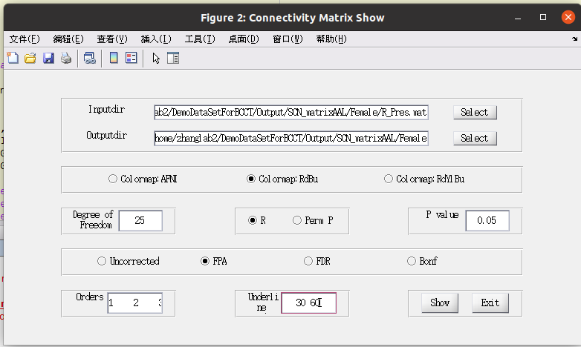Figure 62

Click Show, three figures represent(Figure 63):

Rmatrix(orig, p<0.05 unc, p<0.05 bonf)

Zmatrix(orig, p<0.05 unc, p<0.05 bonf)

Pmatrix(orig, p<0.05 unc, p<0.05 bonf)

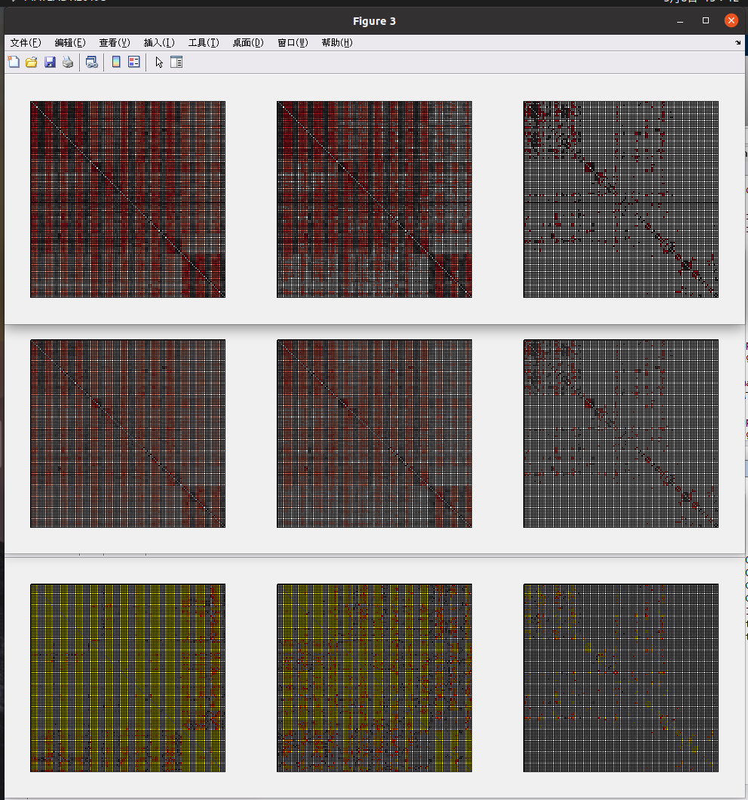Figure 63

There are another three figures represent below(Figure 64):

Rmatrix (FPA correct)

Zmatrix (FPA correct)

Pmatrix (FPA correct)

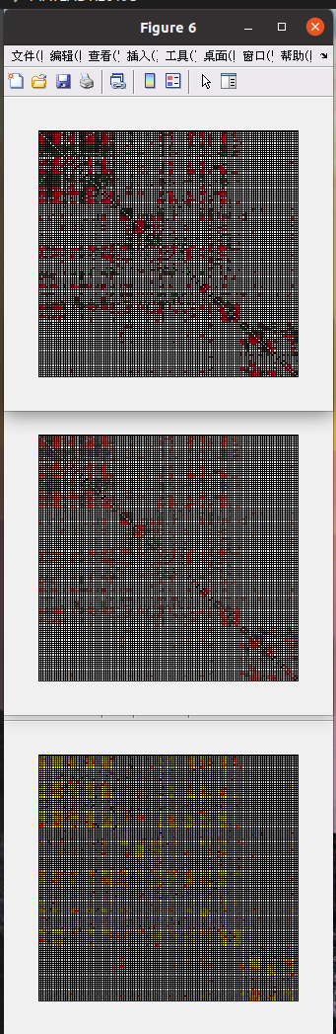Figure 64

The related figures are print to the Outputdir.

7.2.2 Group Comparison of SCN matrix

**7.2.2.a Interaction**

Result folder: InterCompRes.mat contained ‘T’, ‘Z’, ‘P’

Note: p<0.05 means significant changes between Two groups. Also, the T, Z and P matrices are not symmetric for the interaction algorithm. (Y = AX+e, X = BY+E; A is not equal to 1/B, and e is not equal to E).

Currently, we have not make the viewer for this condition. In later version, we would mix this soon.

**7.2.2.b Permutation**

By selecting the permutation result file (‘PermCompRes.mat’), the package would automatically recognize it.

In permutation P result, only colormap of AFNI is used for the result showing.

Here we present results of 6.2 (AAL template, Female vs. Male ROI-wise), with p<0.01 uncorrect (Figure 65)

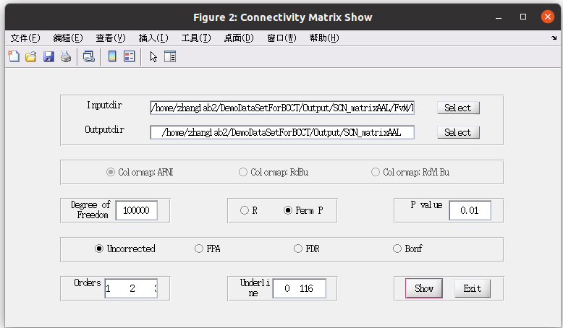Figure 65

In Figure 66:

P(r), P<0.05 uncorrected, P<0.05 Bonf, P<0.01 uncorrected

P(z), P<0.05 uncorrected, P<0.05 Bonf, P<0.01 uncorrected

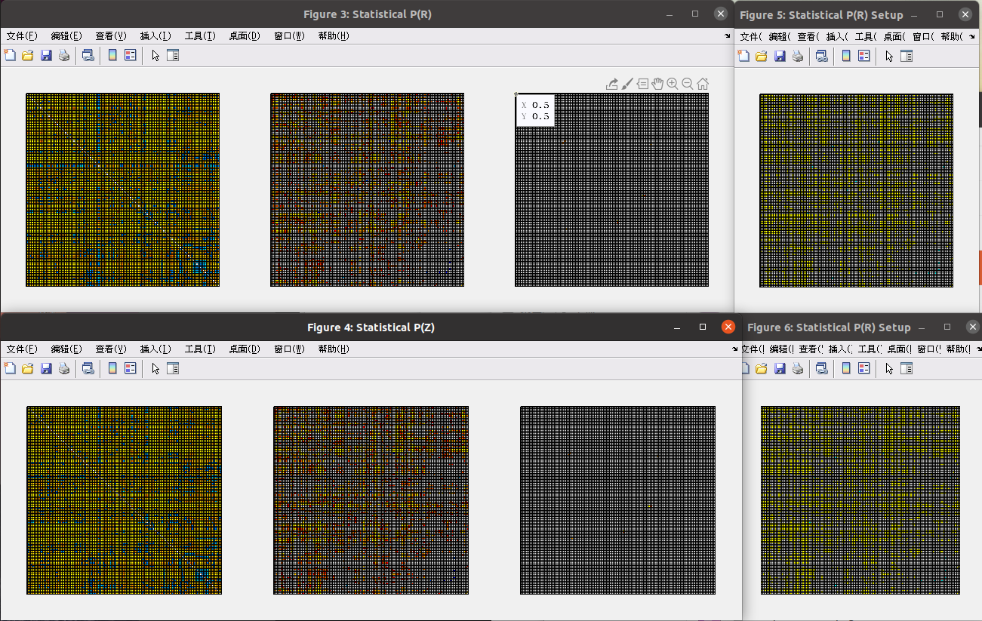Figure 66

7.2.3 MOD-SCN matrix (volume)

Result folder: MOD_tzp_res.mat contained ‘T’, ‘Z’, and ‘P’

Note: p<0.05 means significant changes between Two groups.

Currently, we have not make the viewer for this condition. In later version, we would mix this soon.

7.2.4 Group Comparison of MOD-SCN matrix

Result folder: ResultModfact.mat contained ‘T’, ‘Z’, and ‘P’

Note: p<0.05 means significant changes between Two groups.

Currently, we have not make the viewer for this condition. In later version, we would mix this soon.

7.3 Map(Surface): SCN, MOD-SCN, CaSCN

In Figure 44, please select the template of the Surface in the first line. Then, select the outputdir for the result output. For the SCN/CaSCN/Modulate for one group, please select the related files (For SCN, ‘lh.R_ROI000001.mgh’ or ‘lh.Z_ROI000001.mgh’, Figure 67/68; For MOD-SCN, ‘lh.T_ROI000001.mgh’ or ‘lh.Z_ROI000001.mgh’, Figure 69/70; For CaSCN, ‘lh.ROI00001_X2Y.mgh’ or ‘lh.ROI00001_X2Ytrans.mgh’, Figure 71/72).For interaction test, please select the related files(‘lh.T_ROI000001.mgh’ or ‘lh.Z_ROI000001.mgh’, Figure 73/74). For permutation Test, please select ‘Permutation Test for Group Comparison’, and then select the related P file(‘lh.PermP_??.mgh’), note that this is only for group comparison.

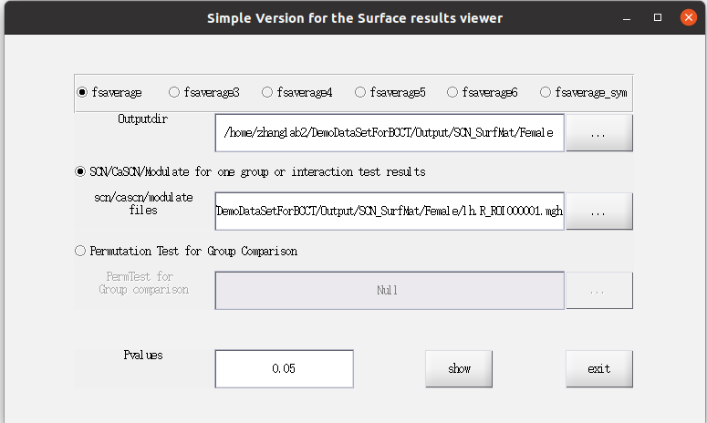Figure 67

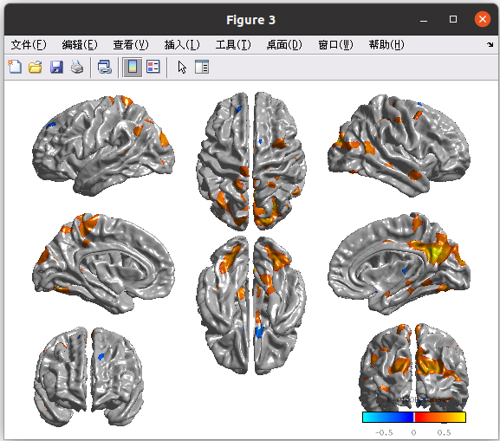Figure 68

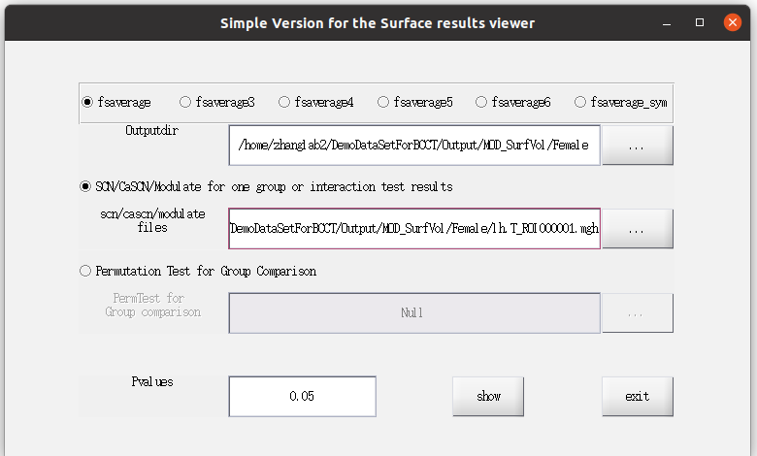Figure 69

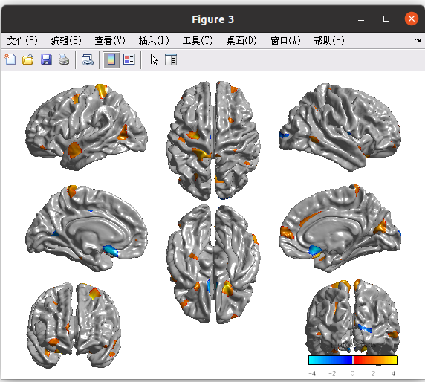Figure 70

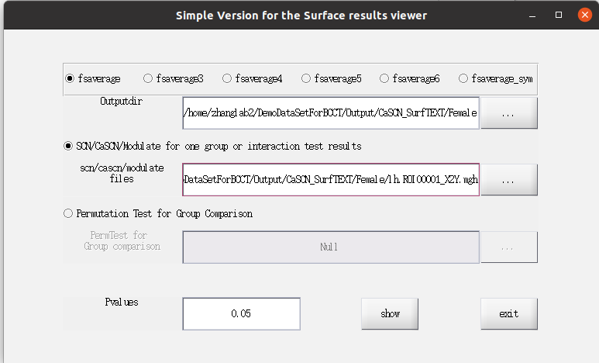Figure 71

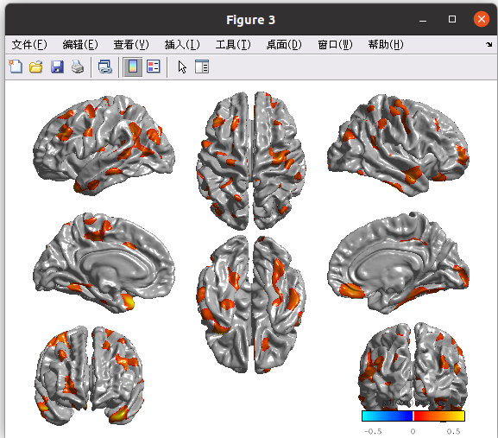Figure 72

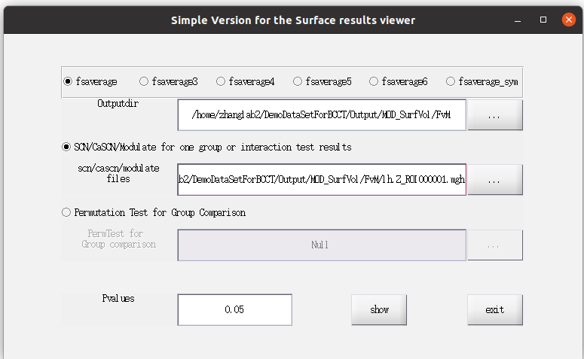Figure 73

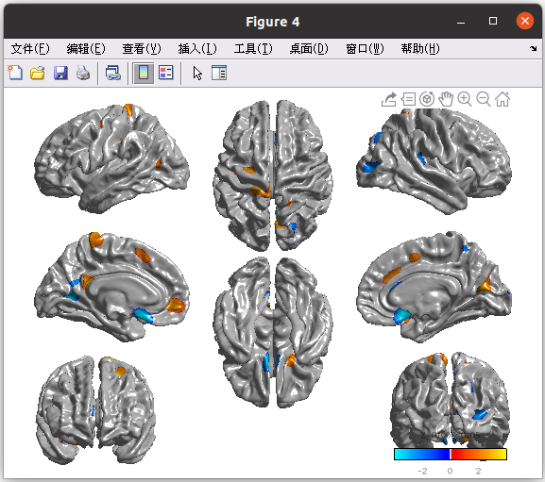Figure 74

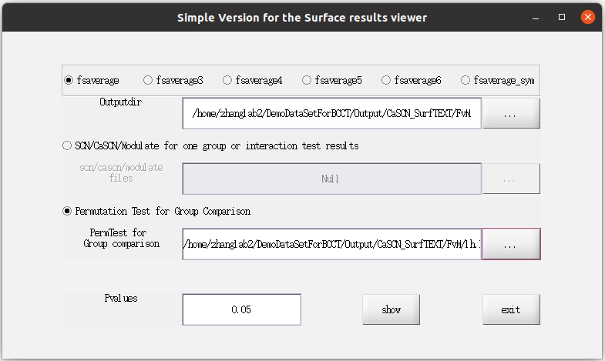Figure 75

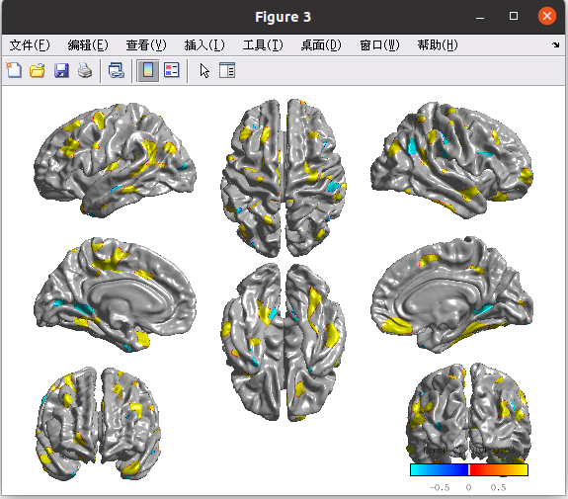Figure 76

7.4 CaSCN Map(Volume)

Click ‘Map(GCA)’ in Figure 43 to Open the GCA type: Residual or Coefficient

7.4.1 Residual

In Figure 77, the intra-group result uses ‘Res map’, and the inter-group result uses ‘Perm Pmap’.

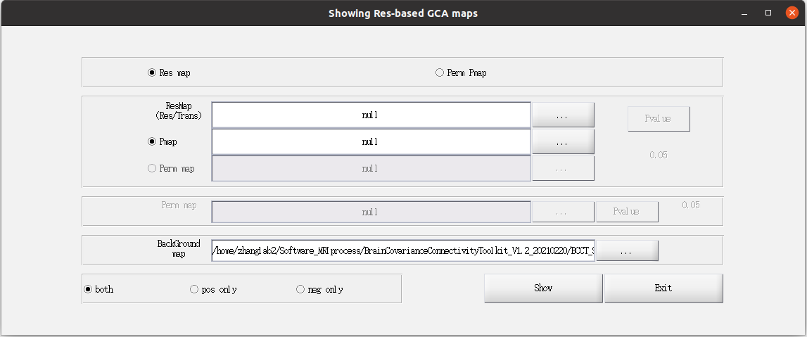Figure 77

For ‘Res Map’, please select ‘ROI0000?_X2Y(Y2X).nii’/ ‘ROI0000?_X2Y(Y2X)_trans.nii’ with related Pvalue map ‘Pval_ROI0000?_X2Y(Y2X).nii’ or Perm Pmap‘Perm_ROI0000?_X2Y(Y2X)(_trans).nii’ (Figure 78).

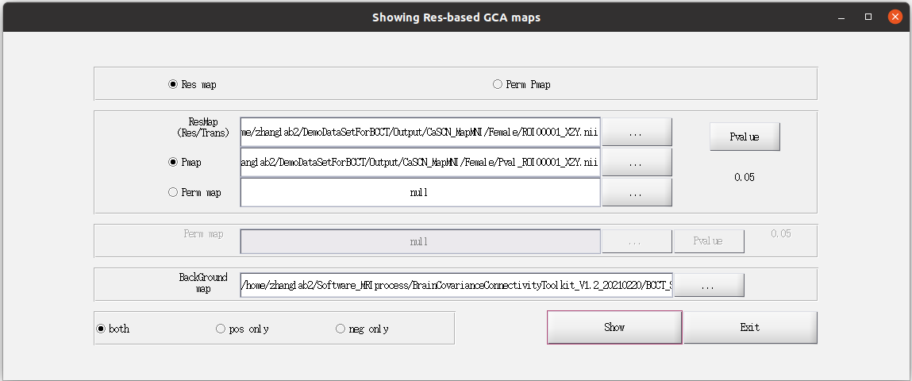Figure 78

After clicking ‘Show’, the following operations are the same as those in 7.1.1(Figure 79).

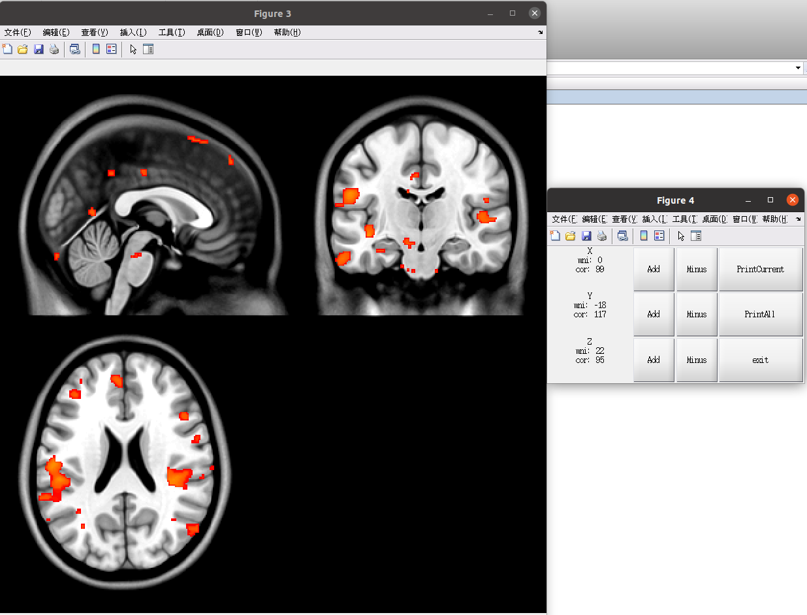Figure 79

For ‘Perm Pmap’, please select the permutation result of group comparison(Figure 80/81). The operations are similar with 7.1.2.c.

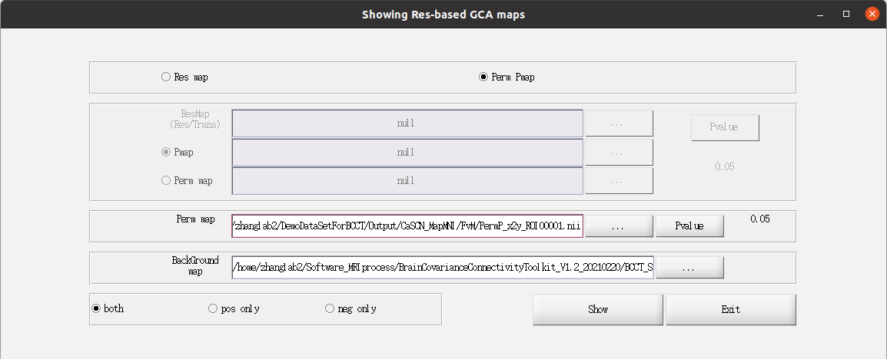Figure 80

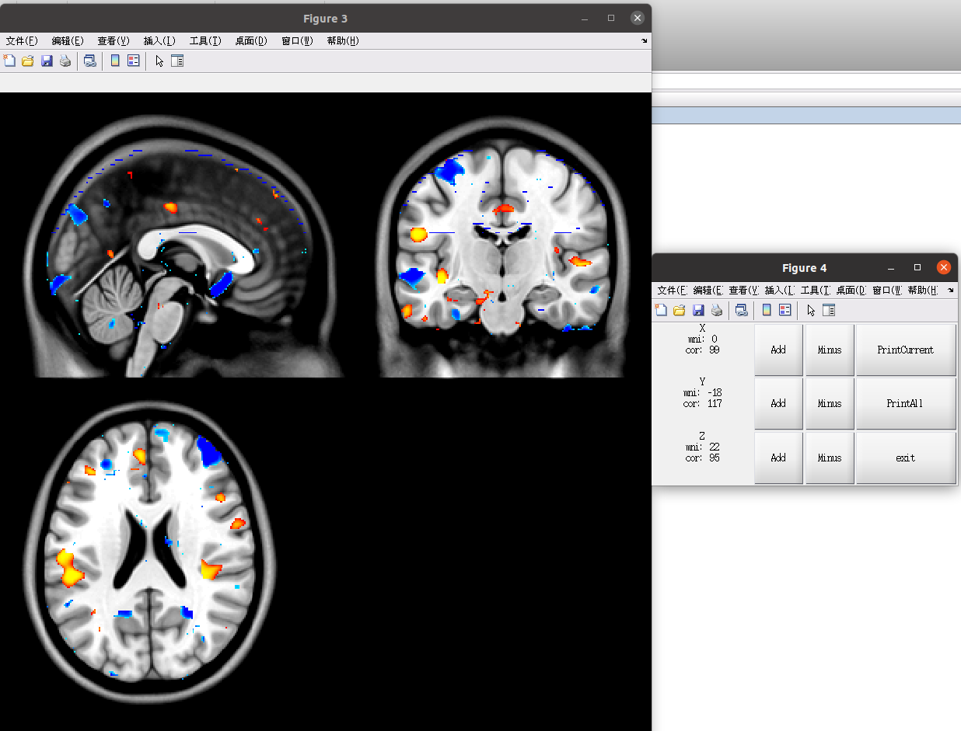Figure 81

7.4.2 Coefficient

Similar to those in 7.4.1

In Coefficient Mode, the results contained

Coef_ROI?_Order_?_X2Y(Y2X).nii

Coef_T_ROI?_Order_?_X2Y(Y2X).nii

Coef_Z_ROI?_Order_?_X2Y(Y2X).nii

with related Pmap (significant p<threshold)

Coef_P_ROI?_Order_?_X2Y(Y2X).nii

if select permutation, the related Pmap (siginificant p<threshold or p>1-threshold)

Coef_Perm_ROI?_Order_?_X2Y(Y2X).nii

Here we present the one example for showing(Figure 82/83).

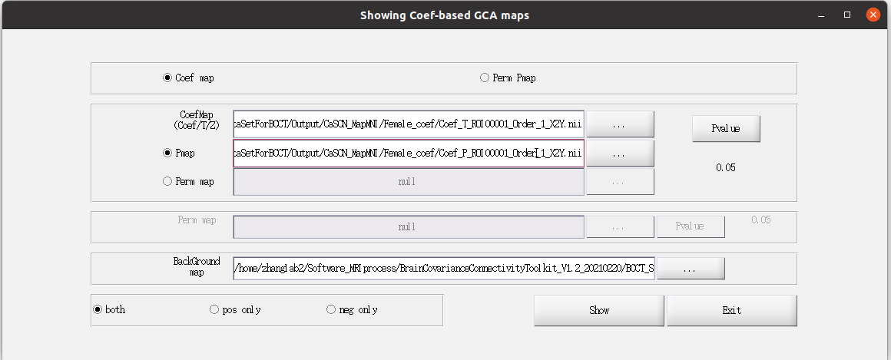Figure 82

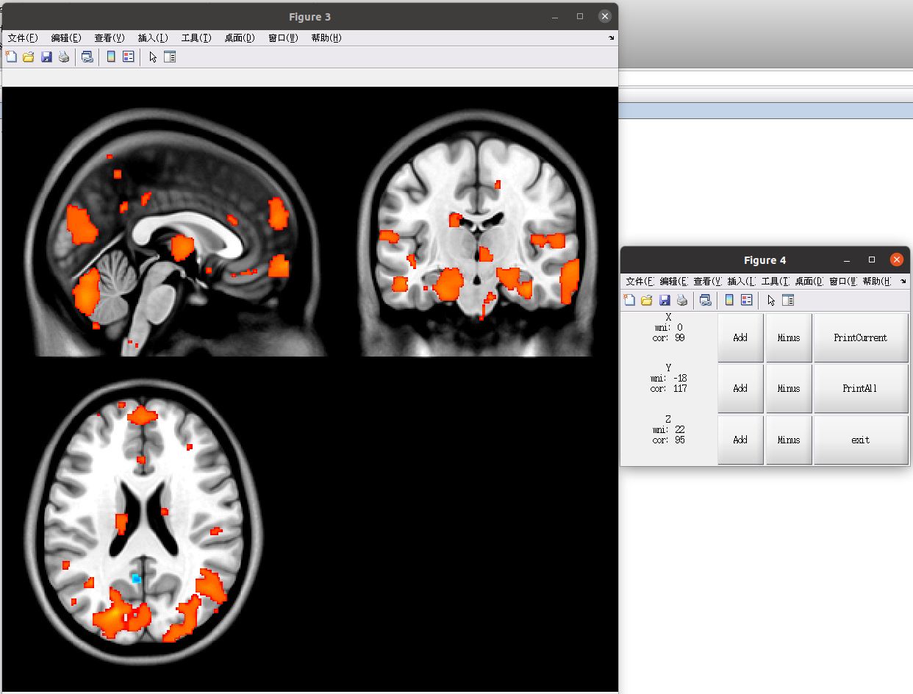Figure 83

7.5 CaSCN Mat(Volume)

Click ‘Mat(GCA)’ to open the setting up window (Figure 84).

In Figure 84,

‘Res’: Residual-based CaSCN,

‘Coef’: Coeficient-based CaSCN,

‘Perm P’: Permutation test of two groups

The other operations are the same as those in 7.2

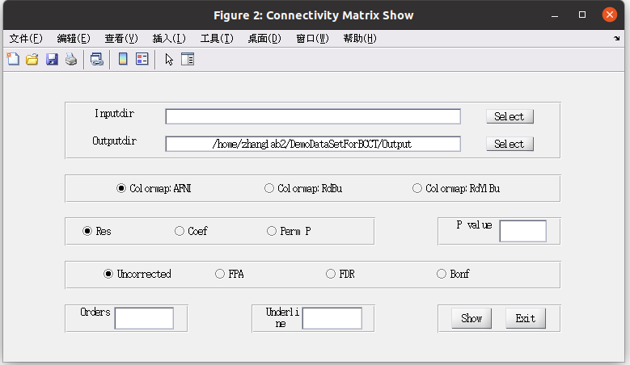Figure 84

7.5.1 Residual-based CaSCN

Result folder: ResultGCA.mat

GCAres.GCA_res_x2y(y2x)(_trans)

related p value:

GCAres.GCA_res_x2y(y2x)_pval, note that p>1-threshold means the significant

if permutation is used, the related perm pval:

GCAres.GCA_res_x2y(y2x)(_trans)_permpval, note that p>1-threshold means the significant

Setting up parameter (Figure 85)

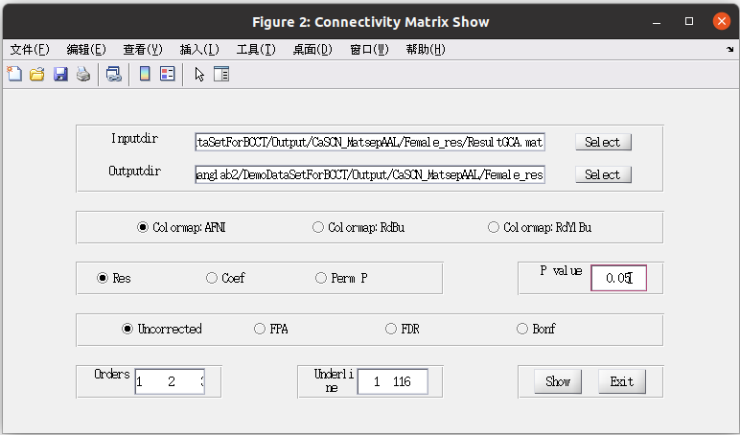Figure 85

Result showing(Figure 86):

X2Y, Y2X, X2Y_trans, Y2X_trans

X2Y_perm, Y2X_perm, X2Y_trans_perm, Y2X_trans_perm, X2Ynet_perm

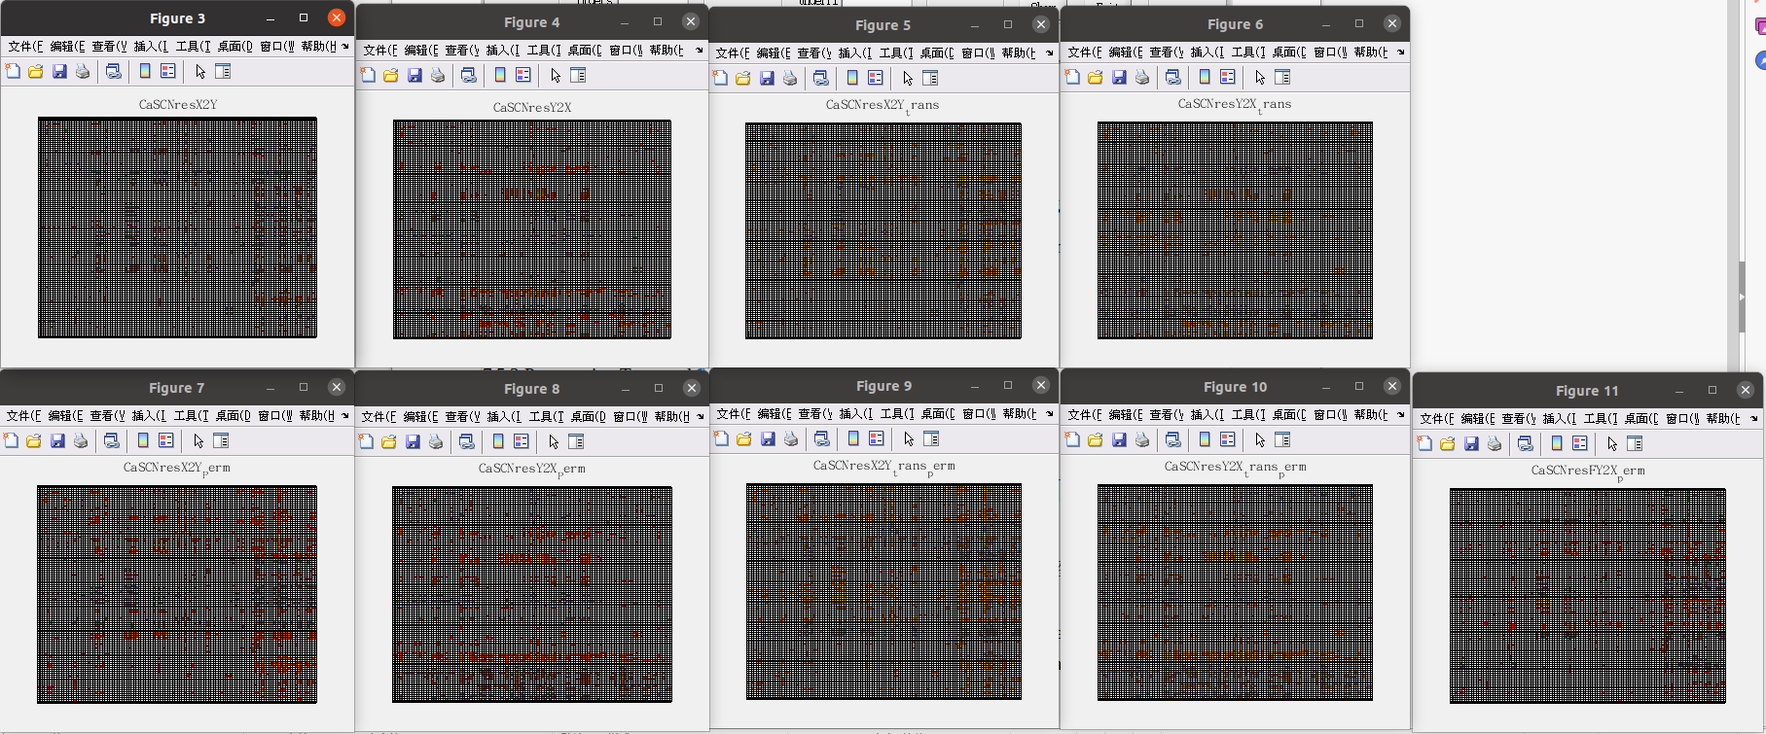Figure 86

7.5.2 Coefficient-based CaSCN

Result folder: ResultGCA.mat

GCAres.GCA_coef_x2y(y2x)(T/Z)

related p value:

GCAres.GCA_coef_x2y(y2x)_pval, note that p<threshold means the significant

if permutation is used, the related perm pval:

GCAres.GCA_coef_x2y(y2x)_permpval, note that p<threshold and p>1-threshold means the significant

Setting up parameter (Figure 87)

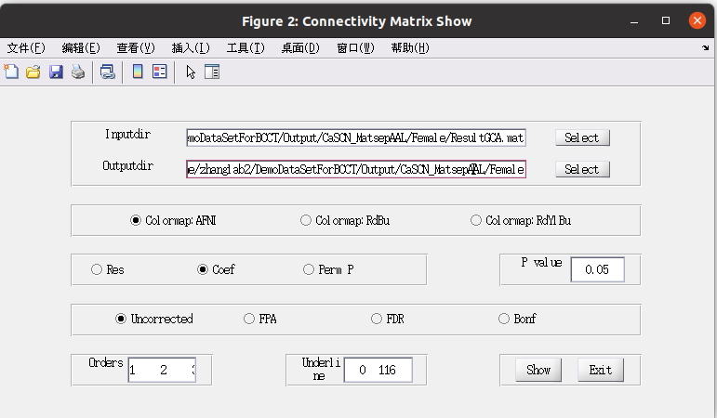Figure 87

Result showing:

X2Y, Y2X, X2Y_Perm, Y2X_Perm

T_X2Y, T_Y2X, Z_X2Y, Z_Y2X

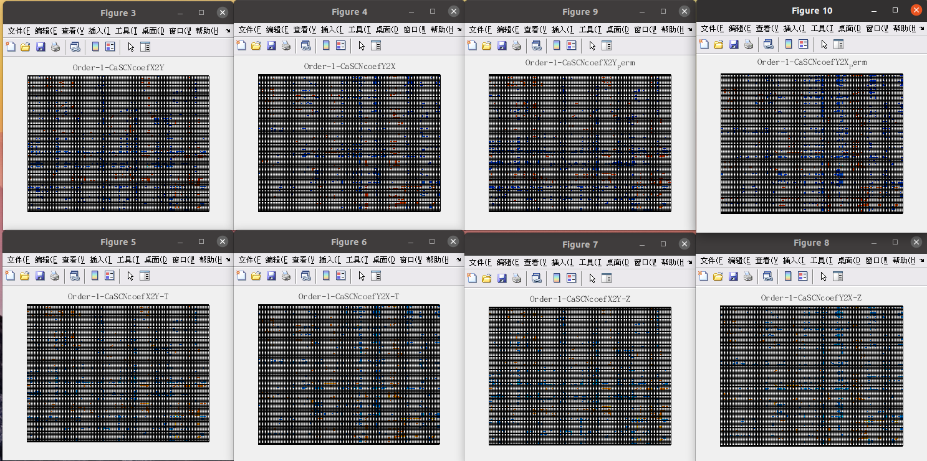Figure 88

7.5.3 Permutation Test result

Result folder:

Residual (Figure 89/90): PermtestForGCA.mat

GroupCompPerm.res.P_mat1: x2y

GroupCompPerm.res.P_mat2: y2x

GroupCompPerm.res.P_mat3: x2y_trans

GroupCompPerm.res.P_mat4: y2x_trans

GroupCompPerm.res.P_mat5: Netx2y

Coefficient (Figure 91/92): Order_1_PermtestForGCA.mat

GroupCompPerm.coef.P_mat1: x2y

GroupCompPerm.coef.P_mat2: y2x

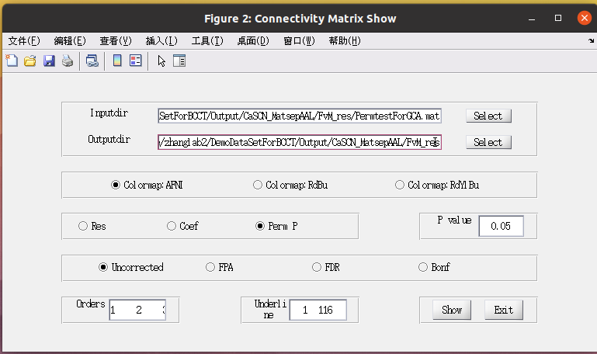Figure 89

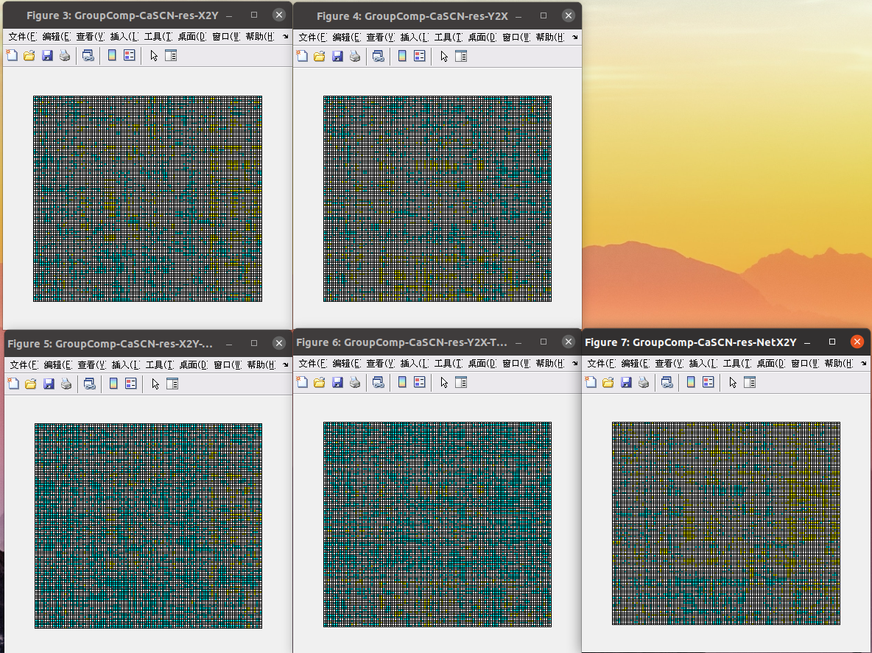Figure 90

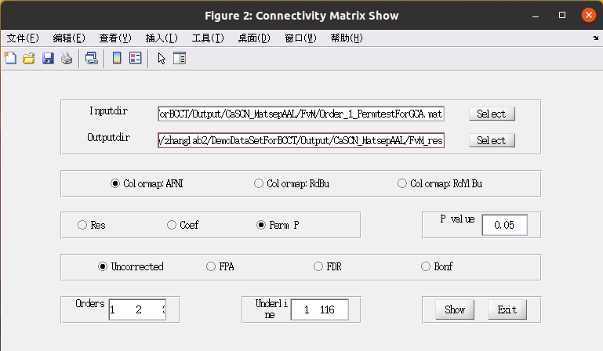Figure 91

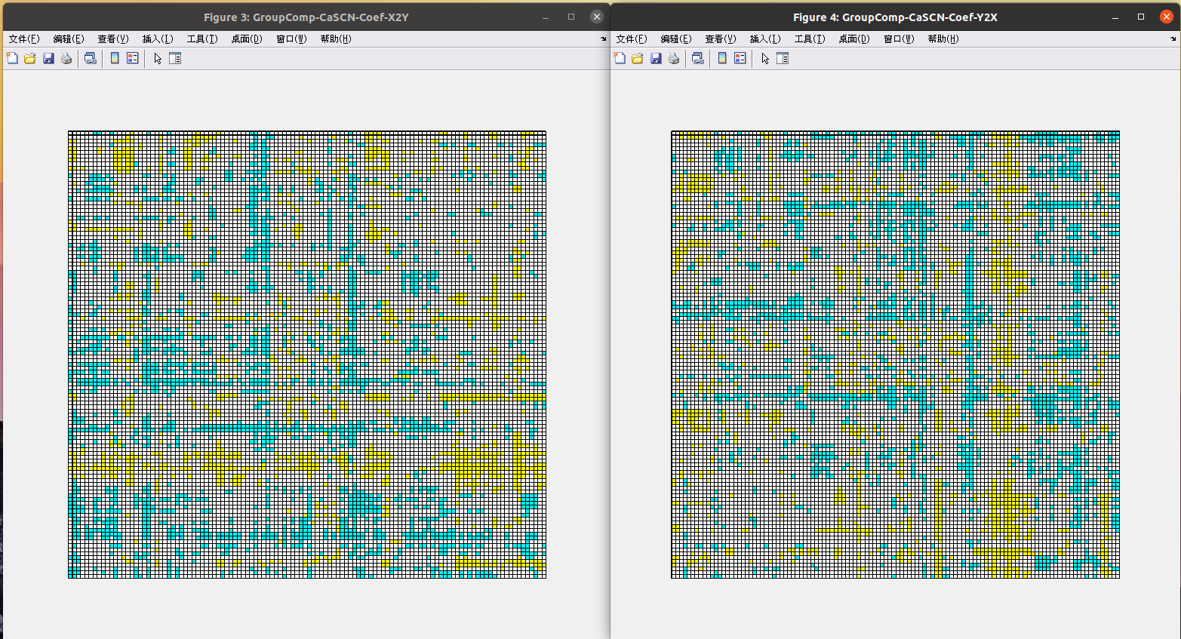Figure 92

7.6 WTA-CSSCN showing

Click the Show Pattern and Radar button in Figure 45, and enter into the Result show interactive interface (Figure 93). First, click the Collect Information button, and into the information collection interface (Figure 94).

The index after Input was the directory of WTA results, and the index after output was the directory of collection information saved, and the index after targetROI was the directory of the target ROI Nifti file. Seed Number should be equal to the seed region’s ROI number, while the Target number could be either 1(Figure 95) or the number of target ROI number (in our example, it could be 3, Figure 96).

After Click OK, we will gain the condition as Figure 97 and 98. Click the button of Show Pattern, it would appear the Pattern result show windows, and click the Show Radar chart, it would appear the radar chart show windows.

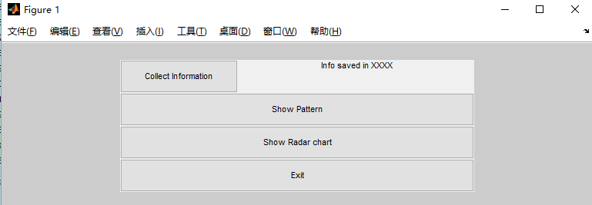

Figure 93

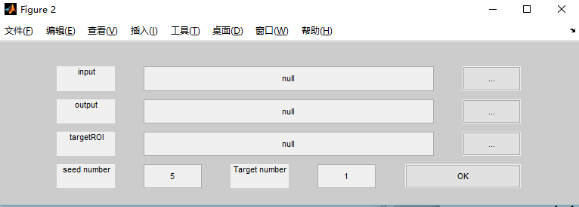

Figure 94

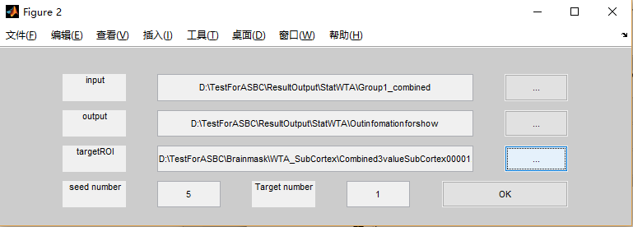

Figure 95

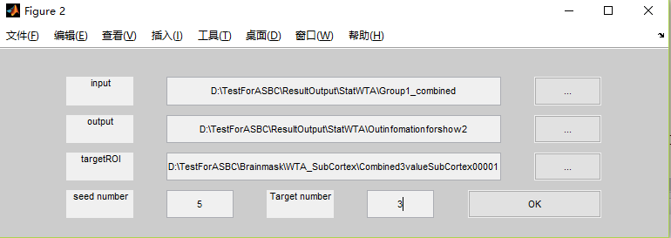

Figure 96

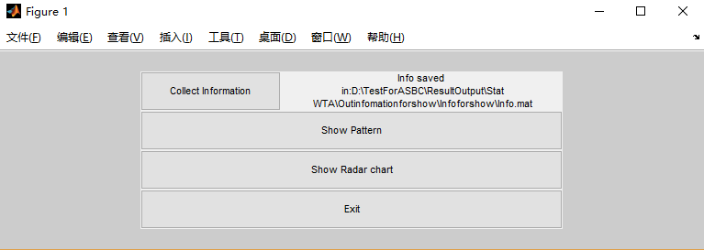

Figure 97

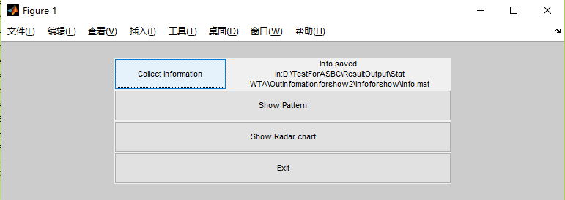

Figure 98

Three windows in the pattern showing mode: 1. Basic information (changes of Axial, Coronal, and Saggital, Figure 99); 2. Combined images with whole brain as background (Figure 100); 3. Combined images with defined ROI multiply Factor (Figure 101).

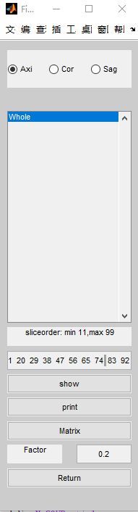 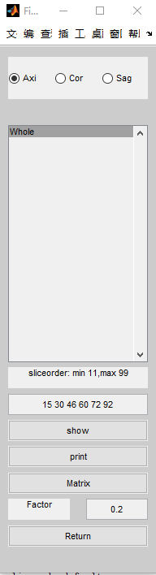 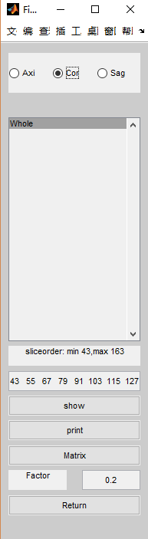

Figure 99

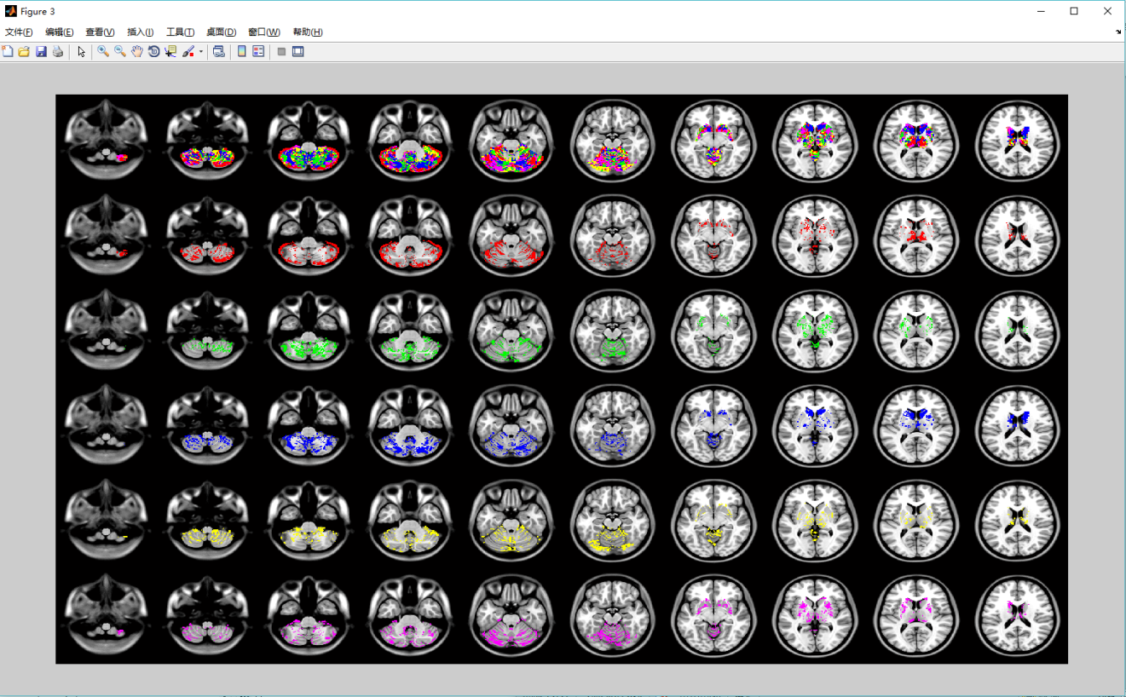

Figure 100

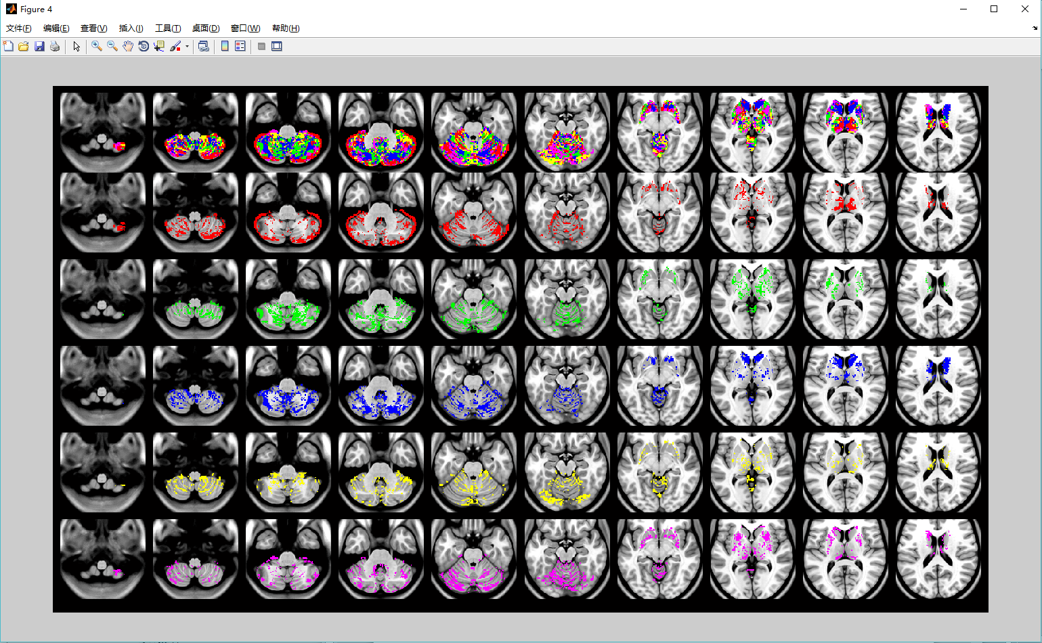

Figure 101

Click ‘Matrix’, the connectivity matrix (Figure 102) and realigned matrix by WTA algorithm (Figure 103) would show.

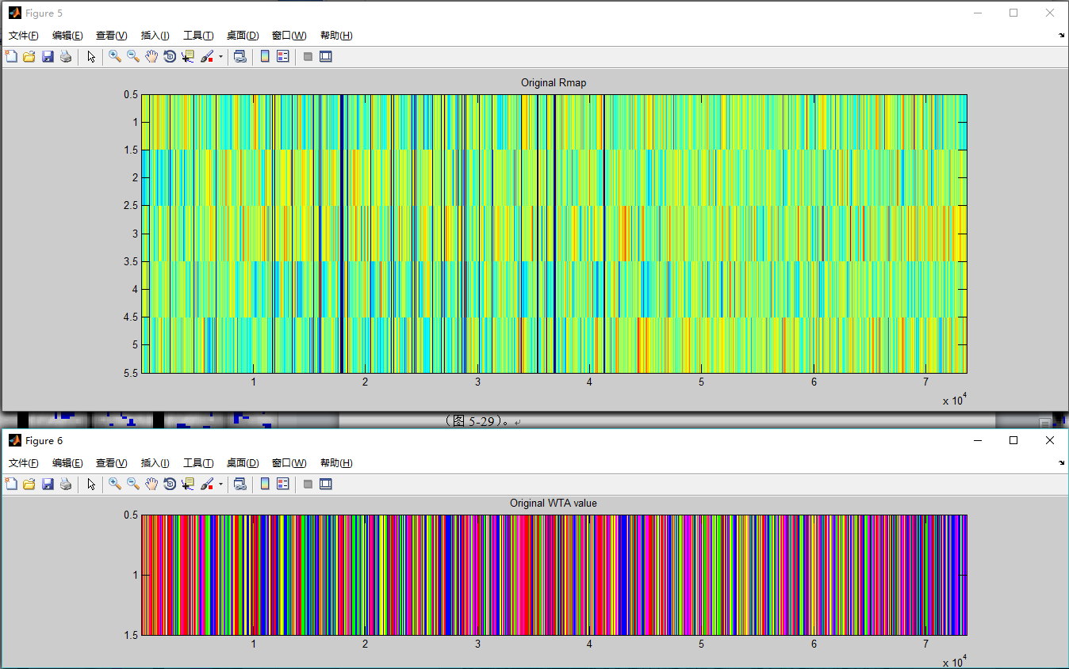

Figure 102

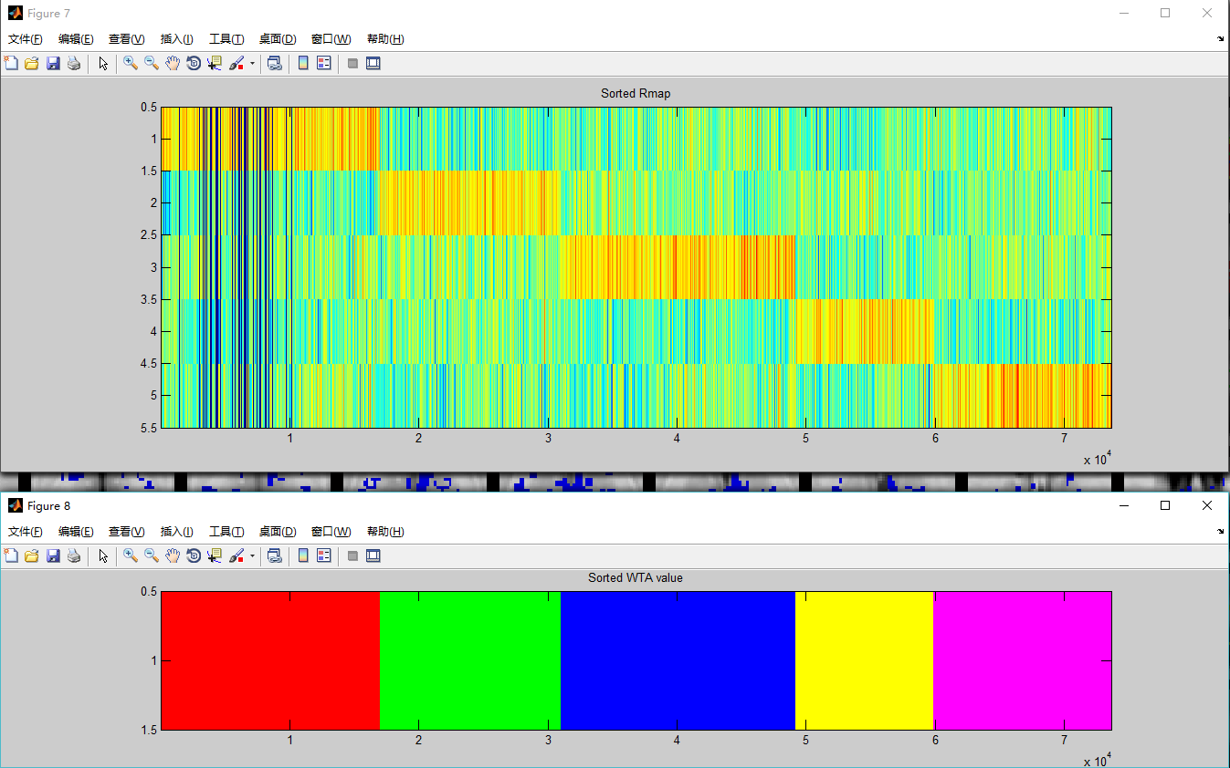

Figure 103

Click ‘Show Radar Chart’, the ratio of voxels connected to the ROIs of seed regions would show: Figure 104 the frequency and ratio figure; Figure 105 the radar chart.

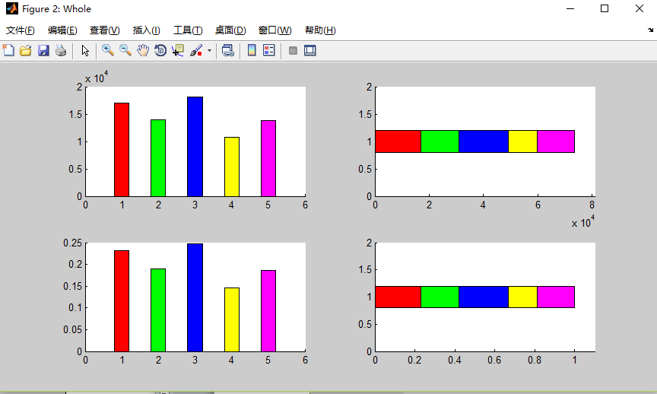

Figure 104

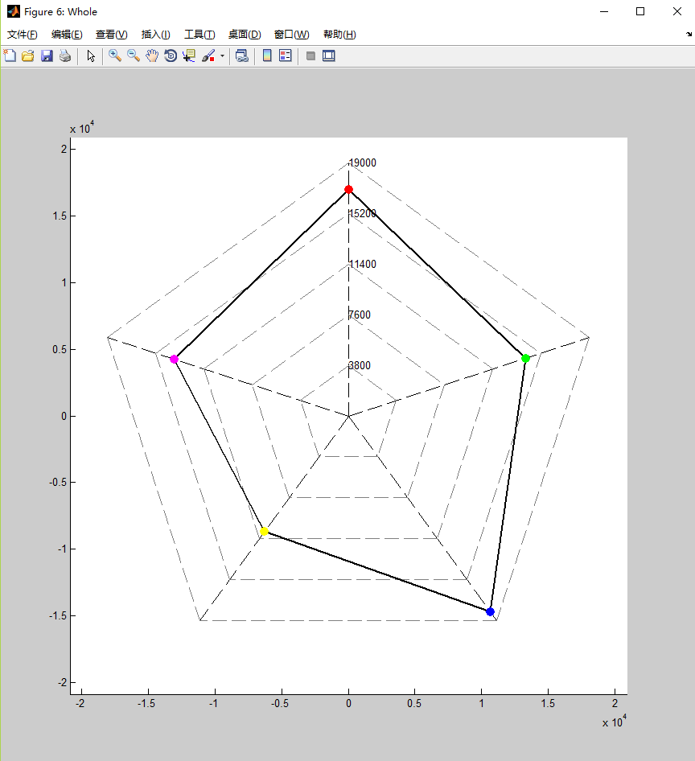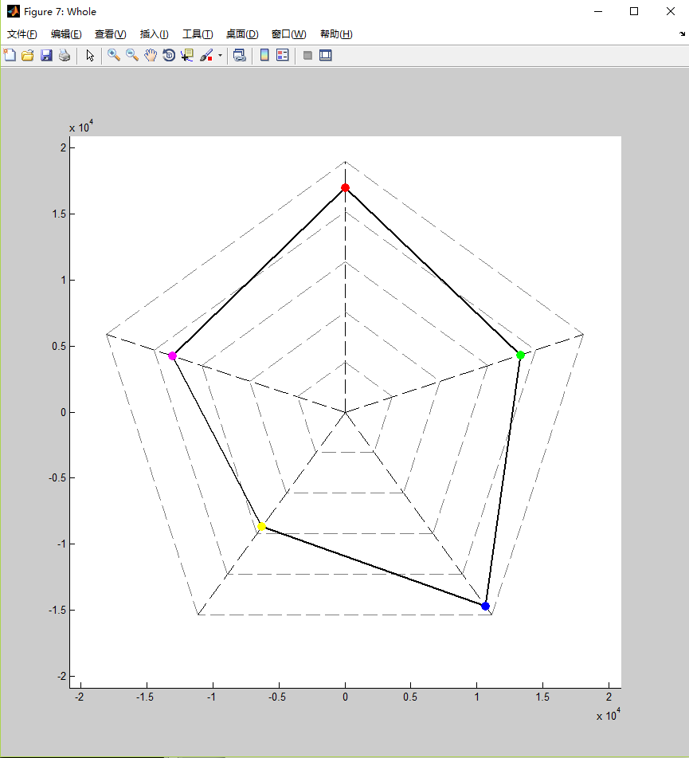

Figure 105

Reference:

1. Xu Q, Zhang Q, Liu G, Dai XJ, Xie X, Hao J, Yu Q, Liu R, Zhang Z, Ye Y, Qi R, Zhang LJ, Zhang Z, Lu G. BCCT: A GUI Toolkit for Brain Structural Covariance Connectivity Analysis on MATLAB. Front Hum Neurosci. 2021 Apr 20;15:641961. doi: 10.3389/fnhum.2021.641961. PMID: 33958993; PMCID: PMC8093864.
2. Xu Q, Zhang Q, Yang F, Weng Y, Xie X, Hao J, Qi R, Gumenyuk V, Stufflebeam SM, Bernhardt BC, Lu G, Zhang Z. Cortico-striato-thalamo-cerebellar networks of structural covariance underlying different epilepsy syndromes associated with generalized tonic-clonic seizures. Hum Brain Mapp. 2021 Mar;42(4):1102-1115. doi: 10.1002/hbm.25279. Epub 2020 Dec 29. PMID: 33372704; PMCID: PMC7856655.
3. Zhang Z, Liao W, Xu Q, Wei W, Zhou HJ, Sun K, Yang F, Mantini D, Ji X, Lu G. Hippocampus-associated causal network of structural covariance measuring structural damage progression in temporal lobe epilepsy. Hum Brain Mapp. 2017 Feb;38(2):753-766. doi: 10.1002/hbm.23415. Epub 2016 Sep 28. PMID: 27677885; PMCID: PMC6866709.